The Effect of Using Mobile apps on the Acquisition of Conditional Sentences among Iranian Intermediate EFL Learners
Elnaz Kourang Beheshti
Elahe Sadeghi*
IJEAP-1901-1342

Abstract
Nowadays, there has been an increasing interest in the integration of technology in pedagogical purposes. This study was an attempt to delve in to the impact of a mobile application (Cushy Grammar) on the learning of conditional sentences (type1, 2 and 3) among Iranian intermediate EFL learners in Rooyesh institute in Isfahan. To this end, a group of 75 intermediate EFL learners were non-randomly placed in three groups. The participants were assigned in two experimental groups, namely Application learning (N=25), Blended learning (N=25), and one Control (N=25).The participants of the Application learning received materials and instructions merely through the app. In the second group, the Blended-based, the participants received traditional teaching methods of grammar (conditional sentences) plus learning via the app. Participants of the control group, however, were taught based on the traditional teaching methods of grammar and received the materials, instructions, and feedback through traditional methods. Data were analyzed using a one-way ANOVA and paired sample t-test to examine the impact of the App learning, Blended learning, and traditional method on the learning of conditional sentences. The results unraveled that the participants of the Application group outperformed two other groups in their learning of conditional sentences. Having a more meticulous look at the results, it was observed that participants of the Control group had a lower performance compared to the experimental groups in the post-test. The results revealed that employing an application learning method could create an appropriate condition to enhance the EFL learners’ acquisition of conditional sentences.
Keywords: Blended Learning, Conditional Sentences, MALL, Mobile Application
1. Introduction
These days the advance and development of technology has resulted in many technological like smartphones, laptops, iPad, and…, that can be applied in the educational process. Accordingly, many universities, colleges and other educational institutes in different countries have started presenting their training program via the internet, in a model known as e-learning. It gives both the teachers and students the ability to communicate within interactive educational environments. In this regard, e-learning is an outstanding assistant in enhancing the quality of teaching and learning (Donoghue, Singh & Singh, 2002). Specifically, technology makes different the way we teach and learn languages. As Blake (2013, 2016) and Stanley (2013) assert, technology prepares new facilities and approaches to teaching which can enhance learner’s motivation and interest.
Devices such as smartphones, tablet computers, laptops, MP3 and MP4 players, and iPads play an important role in teaching process since they give learners the chance to study anytime and anywhere and this type of learning is called “ubiquitous’ learning” (Ogata & Yano, 2004; Yang, 2006). In fact, Keegan (2003) believed that M (mobile)-learning, as a part of e-learning, will alter the future of teaching and learning. Mobile-assisted language learning (MALL) is a fast changing field, one that is supposed to have a great influence on second language teaching and learning (Pachler, Bachmair & Cook, 2010; Thornton & Houser, 2005). Smartphones are considered as a significant instance of omnipresent learning devices, and they are now an important part of many individuals’ life. They are moveable, socially interactive, context-sensitive, connective and individual to language learners (Klopfer, Squire, & Jenkins, 2002). These features are constantly evolving and new functions are being added to meet user needs. For instance, applications such as Twitter, Facebook, Skype, YouTube, Flash-embed or Java-enabled multimedia software are all available for the people on their mobile phones.
In learning a second or foreign language, grammar has always been a challenging and demanding component and is something both language learners and teachers are concerned about, especially in traditional grammar classes. Language learners may not have enough metalinguistic knowledge (i.e., grammar terminology) to find out the topics and explanations of grammar (Hasselgard, 2001). Therefore because of this inefficiency of grammar teaching methods, it is vital to present new approaches and techniques to assist language teachers and learners. That is why this study focused on learning English grammar via mobile app and probes how this app may facilitate learning conditional sentences.
As Chen and Kessler (2013) state utilizing mobile apps in learning languages can be effectual since they are a big part of our social lives today. It is believed that a combination of traditional instruction and on-line instruction, called blended learning (hereafter BL), can be employed in language classrooms. Blended learning can be a practical and effective way to make students attracted and motivated to learn grammar better. Although many experts (Collins, 2005; Ogata, et al., 2006; Kukulska-Hulme, 2006; Sarica & Cavus, 2009; Guerrero, Ochoa, and Collazos, 2010) have stated the benefits of M-learning in teaching English as a foreign, a large number of teachers are not willing to apply M-learning in their classes. M-learning integrates the technologies with communications, and it has now been recognized as an important consciousness-raising tool to learn "anywhere, anytime" (Metcalf II, 2006). However, few research studies have been carried out showing how applying these apps can be actualized in the classroom. Experts enthusiastically want to investigate how different mobile devices can assist learning, and lead to having autonomous students. As stated by Kukulska-Hulme (2012), the experts are willing to gain more about the ways how automatic learning takes place. It seems that mobile apps have the potential to promote learning, however, the researchers wondered if the combination of app learning and classroom learning will affect the knowledge of grammar of EFL learners.
This study aimed to take a step in revealing the operability and exploitability of M-learning. This study explored the effect of a mobile app on learning English as a second/foreign language, specifically for English grammar learning. The primary research aim was to investigate the role of mobile apps and BL in the learning of conditional sentences among Iranian intermediate EFL learners. In this regard, the researcher designed an android application called “Cushy Grammar”.
2. Literature Review
Mobile Assisted Language Learning (MALL), an area of research that has emerged due to the omnipresence of technology, has gained momentum recently. As posed by Wang, Shen, Novak, and Pan (2009), the available literature shows positive attitude of researchers towards MALL; it is also stated by other researchers such as Miangah and Nezarat (2012) and Ono and Ishihara, (2011).
Most studies in the field of MALL focus on vocabulary. Başoğlu and Akdemir (2010) investigated the effect of an online vocabulary learning and flashcards on vocabulary learning. Sixty Turkish EFL students participated in the study. The result indicated that learners using mobile phones outperformed others and they enjoyed more motivation. Lu (2008) gained similar results using paper-based and mobile learning, the results indicated that the m-assisted learning had a noticeable effect on their success in learning vocabulary.
Alemi, Sarab, and Lari (2012) and Çavuş and İbrahim (2009) obtained similar findings, indicating that MALL has benefits for vocabulary learning. However, Zhang, Song, and Burston, (2011) showed the drawbacks of vocabulary learning through MALL. In their study, which included university-level students, it was mentioned that the finding were congruent with former studies. However, the study had other novel implications: mobile phones can result in distractions in learners. Specifically, Hayati, Jalilifar, and Mashhadi, (2013) emphasized that MALL considers a passive role for the teachers, and this is not a positive point, because in the process of teaching and learning, teacher interaction is an effective variable.
Vocabulary learning requires more than memorizing as accurate pronunciation is necessary to be able to use the word appropriately. According to a research conducted by Saran, Seferoglu, and Cagiltay (2009), utilization of mobile phones is an effectual way of learning pronunciation. The population of their study was 24 university-level EFL students learning English in preparatory class. These students were divided into groups, and the results indicated a difference in pronunciation; the group that used mobile devices achieved greater success and accuracy in pronunciation.
Reading is also encountered in MALL literature. Tsou, Wang, and Tzeng (2006) studied online storytelling in their study by developing a website to observe students. In the module, the proficient students were supposed to do activities like composing online multimedia stories easily, then, they had to exchange their own compositions with others. This process led to an improvement in reading. Similarly, Hsu, Hwang, and Chang, (2013) examined reading comprehension of 108 high school EFL population in Taiwan by dividing them into three groups. Results indicated that two experimental groups scored remarkably different in a successful way compared to control group. Finally, grammar acquisition was also examined, albeit infrequently. Baleghizadeh and Oladrostam (2010) divided 40 Iranian students into an experimental group and one control group. The groups were observed in case of a possible improvement in grammar learning, and the results showed that the group using mobile devices scored better in terms of accuracy in grammar. Wang and Smith (2013) examined the effect of a language learning design namely “Ubiquitous English” where they were supposed to write English essays and check grammar via their mobile phones. The results indicated that M-learning had a significant effect on the reading comprehension and grammatical knowledge of students.
Kim and Kwon (2012) explored the common and distinctive features of smartphone apps and critically analyzed the strengths and weaknesses of using them for effective MALL. The results indicated that the ubiquitous accessibility and flexibility nature of current ESL apps appear effective in offering personal and learner-centered learning opportunities. Sole, Calic, and Neijmann (2010) confirmed that learners using mobile phones can easily depict their feelings in different contexts. This research was conducted on two cases within two years in the UK. They wanted students to report their work via mobile phones. The results indicated that exploitation of mobile phones enhanced learners’ interaction and learning.
Many studies have proved the success and the advantages of BL over online and face-to-face learning alone. Students can learn from an online course that matches their different learning styles (Osguthrope & Graham, 2003) and at the same time, they can learn from lectures in class. Besides, the students can learn from social interaction, whether face-to-face or online for developing social communication in HEI‘s (Higher Education Institutions) community and get immediate feedback that increases learners ‘competence and confidence. Based on the above mentioned statements, this study aimed to discover to what extent a blended learning or BL environment can be useful and what the differences among three teaching methods of conditional sentences (i.e., blended, mobile app, and traditional) are. The present study sought to answer the following research questions:
- Does the designed Android application (Cushy Grammar) have a significant effect on the learning of conditional sentences (type 1, 2, and 3) by Iranian intermediate EFL learners?
- Does blended learning have a significant effect on the learning of conditional sentences (type1, 2, and 3) by Iranian intermediate EFL learners?
- Are there any significant differences in the learning of conditional sentences among three groups (i.e., blended, mobile app, and traditional) of Iranian intermediate EFL learners?

3. Methodology
3.1. Participants
The participants of the study were 75 female learners who studied English in Rooyesh language institute in Isfahan. Non-randomized sampling (convenience sample) was utilized for this study. According to the placement test which had been administered by the English language institute, all participants were regarded homogenous in terms of their level of English proficiency. Their age ranged between 14 and 23. It is essential to mention that participants’ gender and age were not considered as independent variables of the study. 75 participants who were at intermediate level were assigned into two experimental groups and one control cohort.
3.2. Design of the Study
Considering some specific characteristics about the study such as hypothesis testing, generalizability, and dealing with numerical data, the present study was considered as a quantitative type. It was a quasi-experimental type, because it was going to benefit from control and two experimental groups who were selected from an intact group of EFL learners, without any randomization.
3.3. Instruments
3.3.1. Mobile Application
The content of the app designed for this study was the same as the content of the traditional classroom content plus more exercises and examples to practice the grammar points (Appendix A). The students in the blended group had the opportunity to use this app content in addition to classroom teaching and feedback. It should be mentioned that the app is concerned with the three types of conditional sentences. The application consists of three lessons which cover the three types of conditional sentences. Every lesson has two parts. Part 1 teaches the grammar point and the second part is a kind of homework which should be sent to the teacher at the end of the lesson. Validity of this app was evaluated by four experts with more than seven years of teaching and testing experience. It should be noted that correct answers were available to students after they emailed their own answers to the teacher and the learners could not reach the next lesson unless they had sent the previous homework to the e-mail which was set in "about us".
3.3.2. Pretest
A researcher-made test was designed to determine the prior conditional sentences knowledge of the participants (Appendix B). The main purpose for designing the pretest was to make sure that participants of the study did not know the conditional sentences. To achieve this goal, 40 multiple-choice items, focusing on different types of conditional sentences were designed. The researcher prepared a forty-item multiple-choice test and did a pilot study on a smaller group. Based on the results of the pilot study and item analysis, 10 items were discarded because some items were too difficult or easy to guess. Therefore, the revised test contained 30 multiple-choice items and was used for both Experimental groups and Control cohort. In order to determine the reliability of the tests, it was administered to a sample of L2 learners (n = 20) as a pilot study who were similar to those participating in the study in terms of age, sex, and the level of proficiency. The results of Cronbach's alpha analysis showed that the test was reliable (r = 0.84). The content validity of the test was evaluated by three experts in the filed with more than five years of teaching and testing experience.
3.3.3. Posttest
In the last session of the study, learners took a post-test, consisting of 30 multiple-choice items to examine the efficiency of the instruction. It is vital to mention that the post test was similar to the pretest. However, to ensure that the learners were not test-wise, the order of the items were different from the pretest and there was six-week interval between these two tests.

3.4. Data Collection Procedure
In order to select and assign participants to groups, participants had to be in an intermediate level because lower intermediate learners are not generally supposed to learn conditional sentences. The placement test had been given by the institute. Therefore, all participants in the sample were homogeneous in terms of proficiency. The participants were assigned non-randomly into three groups, two experimental and one control, each one consisting of 25 participants. A pretest was conducted to ensure that the learners did not know the target grammatical points.
The first experimental group (BL) received the material, teaching, and feedback through both traditional method and the application. Learners in the second experimental group (app) received the materials just through the app. They had no opportunity to have face to face classroom teaching. Students were supposed to do exercises within 24 hours after each session and send the answers to the teacher by e-mail, before starting the next session.
Furthermore, participants could stay in touch with the teacher through both the app and email. The third group, the control group, had the traditional teaching instruction. After the ultimate session of the study, a post-test was administered to find out how participants differed in their performance. It should be noted that the learners were exposed to conditional sentences input twice a week in six sessions, and each session about 90 minutes.
4. Results
The data gathered and elicited in this research study were recorded and then fed into the computer for statistical analysis using SPSS. In order to ensure that learners were homogeneous in their knowledge of conditional sentences, a pretest made up of thirty questions was given to the three groups and the scores were recorded. After that, a one-way ANOVA test was used for the analysis of pretest scores. Furthermore, at the end of the experiment a posttest made up of thirty questions was administered to the three groups to understand the effect of the treatment. Paired-samples t-tests were employed to compare the means before and after the treatment. Moreover, in order to observe the differences among the three groups a one-way ANOVA test was utilized on the posttest scores.
4.1. Homogeneity of Learners concerning Conditional Sentences Knowledge
In order to determine the homogeneity of groups in terms of conditional sentences prior to the study, a conditional-sentence grammar test was administered to all groups as the pretest. A series of thirty conditional sentences tests was given to the students to determine their capacity. By administration of this test the conditional-sentence ability of the three groups was determined. Then, in order to ascertain the homogeneity of all groups according to their ability in conditional sentences, a one-way between-groups analysis of variance (ANOVA) was run to the scores of participants on the pretest.
Table 1: Descriptive Statistics for the Pretest
 | N | Mean | Std. Deviation | Std. Error | 95% Confidence Interval for Mean |  | Minimum | Maximum
 |  |  |  |  | Lower Bound | Upper Bound
control | 25 | 17.4400 | 1.12101 | .22420 | 16.9773 | 17.9027 | 16.00 | 19.00
application | 25 | 17.4800 | 1.15902 | .23180 | 17.0016 | 17.9584 | 15.00 | 19.00
blended | 25 | 17.2800 | 1.40000 | .28000 | 16.7021 | 17.8579 | 15.00 | 20.00
Total | 75 | 17.4000 | 1.21922 | .14078 | 17.1195 | 17.6805 | 15.00 | 20.00

Descriptive statistics for the pretest are represented in table1 In this table the mean scores, standard deviation, and standard error of measurement based on 95% confidence interval are represented. In order to ascertain the equality of groups with regard to their conditional sentences knowledge, the significance level was calculated.

Table 2: The Results of Levene's Test of Equality of Error Variances for the Pretest
Levene’s Statistic | DF1 | DF2 | Sig.
0.831 | 2 | 72 | 0.440

Table 2 shows the results of Levine’s Test of Equality of Error Variances for the participants. Levine’s test was utilized to examine the homogeneity of variances among the groups prior to the study. This test verifies the assumption that variances are equal across groups. As such, the p-value in the last column is F (2, 72) = 0.44 that is much greater than the level of significance (0.05), it can be concluded that the difference between groups was not statistically significant. Therefore, it can be concluded that all participants were homogeneous in terms of their conditional sentences knowledge.

Table 3: Tests of Between-Subjects Effects ANOVA
 | Sum of Squares | DF | Mean Square | F | Sig.
Between Groups | .560 | 2 | .280 | .184 | .832
Within Groups | 109.440 | 72 | 1.520
Total | 110.000 | 74

Table3 represents the tests of between-subjects effects. Accordingly, the dependent variable in conjunction with the pretest is considered in this table. As shown in the table, the values for between-groups, within-groups and then the total values were taken into account. The p-value is .832 that is greater than the level of significance (0.05), so the students were not significantly different regarding their conditional sentences knowledge as compared to the pretest results. The control group and experimental groups were homogeneous.
4.2. Paired Samples t-test for the Application Group
In order to compare the test scores before and after the treatment, a paired sample t-test was employed for the group instructed through the application.
Table 4: Descriptive Statistics for Paired Samples t-test for the application group
 |  | Mean | N | Std. Deviation | Std. Error Mean
Pair 1 | pretest | 17.4800 | 25 | 1.15902 | .23180
 | posttest | 26.5600 | 25 | 2.18098 | .43620

Table 4 depicts the descriptive statistics for the paired samples t-test for the application group. The mean, the number of learners, standard deviation, and standard error mean are depicted in this table.

Table 5: Paired Samples Correlation for the Application Group
 |  | N | Correlation | Sig.
Pair 1 | pretest & posttest | 25 | .417 | .038

Table 6: The Result of Paired Samples t-test for the Application Group
 |  | Paired Differences |  |  |  |  | T | DF | Sig. (2-tailed)
 |  | Mean | Std. Deviation | Std. Error Mean | 95% Confidence Interval of the Difference
 |  |  |  |  | Lower | Upper
Pair 1 | pretest - posttest | -9.08000 | 1.99833 | .39967 | -9.90487 | -8.25513 | -22.719 | 24 | .000

Table5 represents the paired samples correlation for the group taught via application. The number of students, the correlation and the significance level are illustrated in this table. Since the p-value is .038 and it is lower than the level of significance (0.05) and the sig (2-tailed) level in table 6 is zero which is lower than the cut-off point, the conclusion is that application had a statistically significant effect on the learners’ knowledge of conditional sentences.
4.3. Paired Samples t-test for the Blended Group
In order to compare the test scores before and after the treatment, a paired sample t-test was employed for the group instructed through blended environment.
Table 7: Descriptive Statistics for Paired Samples t-test for the blended group
Paired Samples Statistics
 |  | Mean | N | Std. Deviation | Std. Error Mean
Pair 1 | pretest | 17.2800 | 25 | 1.40000 | .28000
 | posttest | 21.3600 | 25 | 1.25433 | .25087

Table 7 depicts the descriptive statistics for the paired samples t-test for the blended group. The mean, the number of learners, standard deviation, and standard error mean are depicted in this table.

Table 8: Paired Samples Correlation for the Blended Group
 |  | N | Correlation | Sig.
Pair 1 | pretest & posttest | 25 | .581 | .002

Table 9: The Result of Paired Samples t-test for the Blended Group
 |  | Paired Differences |  |  |  |  | T | DF | Sig. (2-tailed)
 |  | Mean | Std. Deviation | Std. Error Mean | 95% Confidence Interval of the Difference
 |  |  |  |  | Lower | Upper
Pair 1 | pretest - posttest | -4.08000 | 1.22202 | .24440 | -4.58443 | -3.57557 | -16.694 | 24 | .000

Table 8 represents the paired samples correlation for the blended group. The number of students, the correlation and the significance level are illustrated in this table. Since the significance level is .002 and it is lower than (0.05) and the sig (2-tailed) level in table 9 is zero which is lower than the level of significance, the conclusion is that blended learning had a statistically significant effect on the learners’ knowledge of conditional sentences.
4.4. Differences among the Three Groups Employing One-way ANOVA
In order to elucidate the differences among groups in terms of conditional sentences after the study, a conditional-sentence grammar test was administered to all groups as the posttest. A series of thirty conditional sentences items was given to the students to determine their capacity. By execution of this test the conditional-sentence potential of the three groups was determined. Then, in order to illuminate the differences among groups according to their ability in conditional sentences, a one-way between-groups analysis of variance (ANOVA) was run to the scores of participants on the posttest.
Table 10: Descriptive Statistics for the posttest
 | N | Mean | Std. Deviation | Std. Error | 95% Confidence Interval for Mean |  | Minimum | Maximum
 |  |  |  |  | Lower Bound | Upper Bound
control | 25 | 18.6800 | .94516 | .18903 | 18.2899 | 19.0701 | 17.00 | 20.00
application | 25 | 26.5600 | 2.18098 | .43620 | 25.6597 | 27.4603 | 19.00 | 30.00
blended | 25 | 21.3600 | 1.25433 | .25087 | 20.8422 | 21.8778 | 19.00 | 24.00
Total | 75 | 22.2000 | 3.63169 | .41935 | 21.3644 | 23.0356 | 17.00 | 30.00

Descriptive statistics for the posttest is represented in table 10 In this table the mean scores, standard deviation, and standard error of measurement based on 95% confidence interval are represented.

Table 11: The Results of Levene's Test of Equality of Error Variances for the Posttest
Levene’s Statistic | DF1 | DF2 | Sig.
3.612 | 2 | 72 | .032

In order to delineate the differences among groups with regard to their conditional sentences knowledge, the significance level was calculated. Table11 shows the results of Levene’s Test of Equality of Error Variances for the participants. As such, the p-value in the last column is F (2, 72) = 0.032 that is lower than the level of significance (0.05), it can be concluded that there were differences among the control group and experimental cohorts in terms of their ability in conditional sentences.

Table 12: Tests of Between-Subjects Effects
 | Sum of Squares | DF | Mean Square | F | Sig.
Between Groups | 802.640 | 2 | 401.320 | 166.677 | .000
Within Groups | 173.360 | 72 | 2.408
Total | 976.000 | 74

Table 12 represents the tests of between-subjects effects. Accordingly, the dependent variable in conjunction with the posttest is taken into account in this table. The one-way ANOVA was utilized to identify sum of squares, degree of freedom, mean square, frequency, and significance in various columns. As shown in table 12, the values for between-groups, within-groups and then the total values are taken into account. The students in the three groups were different regarding their conditional sentences knowledge. The p-value is zero which is less than the level of significance (0.05). As a result, there were differences in terms of learning conditional sentences among control and experimental groups.
Table 13: Post Hoc Tests, Multiple Comparisons
(I) groups | (J) groups | Mean Difference (I-J) | Std. Error | Sig. | 95% Confidence Interval
 |  |  |  |  | Lower Bound | Upper Bound
Control | application | -7.88000* | .43889 | .000 | -8.9770 | -6.7830
 | blended | -2.68000* | .43889 | .000 | -3.7770 | -1.5830
application | control | 7.88000* | .43889 | .000 | 6.7830 | 8.9770
 | blended | 5.20000* | .43889 | .000 | 4.1030 | 6.2970
Blended | control | 2.68000* | .43889 | .000 | 1.5830 | 3.7770
 | application | -5.20000* | .43889 | .000 | -6.2970 | -4.1030
*. The mean difference is significant at the 0.05 level.

According to Table 13, Post hoc tests, multiple comparisons using Scheffe tests were carried out in order to locate theexact differences in the performances of the target groups. This test systematically compares each pair of groups, and indicates that a significant difference has been found in the mean scores of control, application, and blended groups since p value is .000 that is less than the level of significance (0.05).
5. Discussion
The results of paired sample t-test for the application group showed that the p-value has been lower than the level of significance. Compared to the results of control group, experimental group had much more achievement. It can be concluded that the android application had a statistically significant effect on conditional sentences knowledge of Iranian intermediate EFL learner. The results of the study are in line with Wang and Smith’s findings (2013) where m-learning is considered to be an effective method for enhancing students’ grammar knowledge.
Given its many benefits and advantages, learning through mobile can be considered as the effective modern method of education. The main characteristics of mobile learning (m-learning) are recognized as the potential for learning process to be personalized, spontaneous , informal and ubiquitous(Mosavi-Miangah&Nezarat, 2012). Also, one of the most obvious features of mobile learning is its availability. Therefore, learning through the mobile phone or m-learning provides the learners with the opportunity to learn when they are in the bus, outside or at work doing their part-time jobs. The results of the current study are further considered as a proof for Mosavi-Miangah & Nezarat’s findings (2012), where learners can learn every time and everywhere using their mobile phones.
Based on the results of statistical analysis, it was concluded that knowledge of conditional sentences was enhanced by the blended learning. The results of paired sample t-test for the blended group showed that the p-value was less than the level of significance. In comparison to the control group, the treatment in the blended group was more effective. It can be concluded that the blended learning had a statistically significant influence on the acquisition of conditional sentences among Iranian intermediate EFL learners. The results of the study are also in line with Osguthrope and Graham’s (2003) in case of positive effect of BL on learning. The results also indicated that although both methods in application and blended groups enhanced conditional sentences knowledge from the pretest to the posttest, the application group seemed to benefit more from the blended group. And the control group had the least enhancement that is, in the end, the participants of the application group had significantly better knowledge of conditional sentences than those of the blended and control group.
As for the third research question, a one-way between-groups analysis of variance was run on the scores of participants on the posttest to illuminate that there were differences among experimental groups and the control cohort. It can be seen from Table 11 that the p-value (0.032) is lower than the level of significant which shows the differences among three method. Post hoc test, multiple comparisons using Scheffe tests were carried out to locate the exact differences in the performance of the groups, and it is obvious that application group had the best performance. It seems that Using mobile phone every time anywhere among the young generation leads to this result.
Of course it is necessary to mention that there are studies which have had positive results using mobile application learning method which was presented in this study. For instance, the results of the current study are in line with Baleghizadeh and Oladrostam’s (2010) in case of an improvement in grammar learning, and the results showed that the group using mobile devices scored significantly better in terms of accuracy in grammar.
6. Conclusion and Implications
A few conclusions could be drawn from the findings of this research that help English language teachers and learners in both public and private schools to have some insights about teaching and learning English grammar, especially conditional sentences. The results of this study indicated that the proposed mobile application namely Cushy Grammar had a significant effect on learning the target structures (conditional sentences). Moreover, applying technology in classes and learning through it can improve activity engagement. The results of this study also showed that student-centered classes and interactive education can be achieved through the application of technology in EFL classes.
For all the three methods, it was found that the pretest and posttest results had a significant difference. Thus, these methods of instruction can affect learners' performance in learning and producing grammar. The findings revealed that among three groups, the application was the best method to be used in the grammar class as it helped to improve participants' score. The finding unravels that if teachers encourage their students to use the internet, computer, and mobile more, their knowledge improves significantly. This is because learners will enjoy using the benefits of technology in learning and can understand grammar lessons (e.g., the conditional sentences) more efficiently and easily. BL can now be considered as a novel notion at many language institutes.
Although findings of available studies generally reveal that if mobile devices are applied "appropriately", blended learning can raise learning (Marsh, 2012), the results of current study indicate that mere use of mobile apps has been more beneficial to Iranian EFL students. This result can be justified in that in Iran the young generation are highly engaged with their mobile phones everywhere and every time and this device and apps take many hours of their time. In this way, they might be more willing to use this device to enhance their own learning too.
From a pedagogical vantage point, the application of blended learning may present helpful insights for EFL teachers, learners and syllabus designers for teaching and learning grammar, especially conditional sentences. It is believed that the results of this study can contribute to a better understanding of the role technology plays in the process of language teaching and learning, especially in teaching grammar. The findings of this study lead to the following recommendations: Having an application designer to support M-learning might be helpful for English language classes.
Considering the students’ needs and interests could be beneficial for designing an English language curriculum in institutes and schools. Being aware of different learning aids that facilitate, attract, and motivate students’ attention in an application learning class can be necessary for syllabus designer as well. It can be important for syllabus designer to integrate courses with appropriate software application to gain effectual results. Syllabus designers and curriculum developers can be informed that in the technology era and because of excessive use of mobile phones among the young generation, it is vital to employ whatever possible (the apps, internet and mobiles) to promote learning specially grammar. English teachers specifically can teach course contents along with MALL. To this end, teachers can be kept update with a well-organised worksheet, demonstrating accessible softwares so that the teachers exploit an appropriate one without wasting too much time.

Reference
Alemi, M., Sarab, M. R. A., & Lari, Z. (2012). Successful learning of academic word list via MALL: Mobile assisted language learning. International Education Studies, 5(6), 99-109. http://dx.doi.org/10.5539/ies.v5n6p99
Baleghizadeh, S., & Oladrostam, E. (2010).The effect of mobile assisted language learning (MALL) on grammatical accuracy of EFL students. MEXTESOL Journal, 34(2), 1-10.
Başoğlu, E. B., &Akdemir, O. (2010). A Comparison of Undergraduate Students' English Vocabulary Learning: Using Mobile Phones and Flash Cards. Turkish Online Journal of Educational Technology, 9(3), 1-7.
Blake, R. (2013). Brave New Digital Classroom: Technology and Foreign Language Learning (2nd ed.). Washington, D.C.: Georgetown University Press.
Blake, R. (2016). Technology and the four skills. Language Learning and Technology, 20(2), 129-142.
Cavus, N., & Ibrahim, D. (2009). m‐Learning: An experiment in using SMS to support learning new English language words. British Journal of Educational Technology, 40(1), 78-91. http://dx.doi.org/10.1111/j.1467-8535.2007.00801.x
Chen, X. B., & Kessler, G. (2013). Action Research Tablets for Informal Language Learning: Student Usage and Attitudes. Language, Learning and Technology, 17(1). Retrieved from http://hdl.handle.net/10125/24503 on 28.12.2015
Collins, T. G. (2005). English Class on the Air: Mobile Language Learning with Cell Phones. Paper presented at the Fifth IEEE International Conference on Advanced Learning Technologies (ICALT’05). Retrieved from http://doi.ieeecomputersociety.org/10.1109/ICALT.2005.137
Donoghue, J., Singh, G. and Singh, J. (2002) “Implication for planning E-learning strategy in higher education institutions”, Academic Education Quarterly, Vol. 6, No. 4.
Guerrero, L. A., Ochoa, S., Collazos, C. (2010). A mobile learning tool for improving grammar skills. Procedia Social and Behavioral Sciences, 2, 1735–1739.
Hasselgard, H. (2001). “Grammar in Communicative English Teaching”. Spark of Sprogundervisning, 1, 7-12.
Hayati, A., Jalilifar, A., & Mashhadi, A. (2013).Using Short Message Service (SMS) to teach English idioms to EFL students. British Journal of Educational Technology, 44(1), 66-81. http://dx.doi.org/10.1111/j.1467-8535.2011.01260.x
Hsu, C. K., Hwang, G. J., & Chang, C. K. (2013).A personalized recommendation-based mobile learning approach to improving the reading performance of EFL students. Computers and Education, 63, 327-336. http://dx.doi.org/10.1016/j.compedu.2012.12.004
Jones, G., Edwards, G., & Reid, A. (2009). How can mobile SMS communication support and enhance a first year undergraduate learning environment? Research in Learning Technology, 17(3), 201-218. http://dx.doi.org/10.1080/09687760903247625
Keegan, D. (2003). The Future of Learning: From eLearning to mLearning. Hagen: Fernstudienferchung, Germany. E-published version retrieved June 2, 2106from http://learning.ericsson.net/leonardo/thebook/
Kim, H., & Kwon, Y. (2012). Exploring smartphone applications for effective mobile-assisted language learning. Multimedia-Assisted Language Learning, 16(1), 31-57.
Klopfer, E. Squire, K., & Jenkins, H. (2002). Environmental detectives: PDAs as a window into a virtual simulated world. In Proceedings of IEEE International Workshop on Wireless and Mobile Technologies in Education (pp. 95-98). Vaxjo, Sweden: IEEE Computer Society.
Kukulska-Hulme, A. (2006). Mobile language learning now and in the future. In Svensson, Patrik (ed.) Från vision till praktik: Språkutbildning och Informationsteknik (From vision to practice: language learning and IT) (pp.295–310).Sweden: Swedish Net University (Nätuniversitetet).
Kukulska-Hulme, A. (2012). Language learning defined by time and place: A framework for next generation designs. In D´iaz-Vera, E. Javier (Eds.), Left to my own devices: Learner autonomy and mobile assisted language learning. Innovation and leadership in English language teaching, (pp.1-13). Bingley: Emerald Group Publishing Limited.
Lu, M. (2008). Effectiveness of vocabulary learning via mobile phone. Journal of Computer Assisted Learning, 24(6), 515-525. Doi:10.1111/j.1365-2729.2008.00289.x
Miangah, T. M., & Nezarat, A. (2012). Mobile-assisted language learning. International Journal of Distributed and Parallel Systems, 3(1), 309-319. http://dx.doi.org/10.5121/ijdps.2012.3126
Ogata, H., & Yano, Y. (2004). Context-aware support for computer-supported ubiquitous learning. In Proceedings of the 2nd IEEE International Workshop on Wireless and Mobile Technologies in Education (pp. 27-34). Washington, D.C.: IEEE Computer Society.
Ogata, H., Yin, C., Paredes, R. G., Saito, J. N. A., Yano, Y., Oishi, Y., & Ueda, T. (2006). Supporting Mobile Language Learning outside Classrooms, proceedings of the Sixth International Conference on Advanced Learning Technologies (ICALT'06). https://doi.org/10.1109/ICALT.2006.1652595
Ono, Y., & Ishihara, M. (2011). The mobile-based training in an EFL classroom. 2011 International Conference on Computers in Education (pp. 422-424). Retrievedfromhttp://www.nectec.or.th/icce2011/program/proceedings/pdf/C4_P1_77.pdf on 29.11.2015
Osguthorpe, R. T., & Graham, C. R. (2003). Blended learning systems: definitions and directions. The Quarterly Review of Distance Education, 4(3), 227–234.
Pachler, N., Cook, J., & Bachmair, B. (2010). Appropriation of mobile cultural resources for learning. International Journal of Mobile and Blended Learning, 2(1), 1-21.
Saran, M., Seferoglu, G., &Cagiltay, K. (2009). Mobile assisted language learning: English pronunciation at learners' fingertips. Eurasian Journal of Educational Research, 34(1), 97-114. Retrieved from http://94.73.145.182/0DOWNLOAD/pdfler/tr/902903948.pdf on 29.11.2015
Sarica, G. N. & Cavus, N. (2009). New trends in 21st Century English learning. Procedia Social and Behavioral Sciences. 1, 439–445.
Sole, R.C, Calic, J., and Neijmann, D. (2010). A social and self-reflective approach to MALL. ReCALL, 22, 39-52.
Stanley, G. (2013). Language Learning with Technology: Ideas for Integrating Technology in the Classroom. Cambridge: Cambridge University Press.
Thornton, P., & Houser, C. (2005). Using mobile phones in English education in Japan. Journal of Computer Assisted Learning, 21, 217-228.
Tsou, W., Wang, W., &Tzeng, Y. (2006).Applying a multimedia storytelling website in foreign language learning. Computers& Education, 47(1), 17-28. http://dx.doi.org/10.1016/j.compedu.2004.08.013
Wang, S., & Smith, S. (2013). Reading and grammar learning through mobile phones. Language Learning and Technology, 17(3), 117-134.
Wang, M., Shen, R., Novak, D., & Pan, X. (2009). The impact of mobile learning on students' learning behaviors and performance: Report from a large blended classroom. British Journal of Educational Technology, 40(4), 673-695. http://dx.doi.org/10.1111/j.1467-8535.2008.00846.x
Yang, S. J. H. (2006). Context aware ubiquitous learning environments for peer to peer collaborative learning. Educational Technology and Society, 9, 188-201.
Zhang, H., Song, W., &Burston, J. (2011). Reexamining the Effectiveness of Vocabulary Learning via Mobile Phones. Turkish Online Journal of Educational Technology-TOJET, 10(3), 203-214. Retrieved on 29.11.2015 from http://files.eric.ed.gov/fulltext/EJ944968.pdf

Appendix A
Application
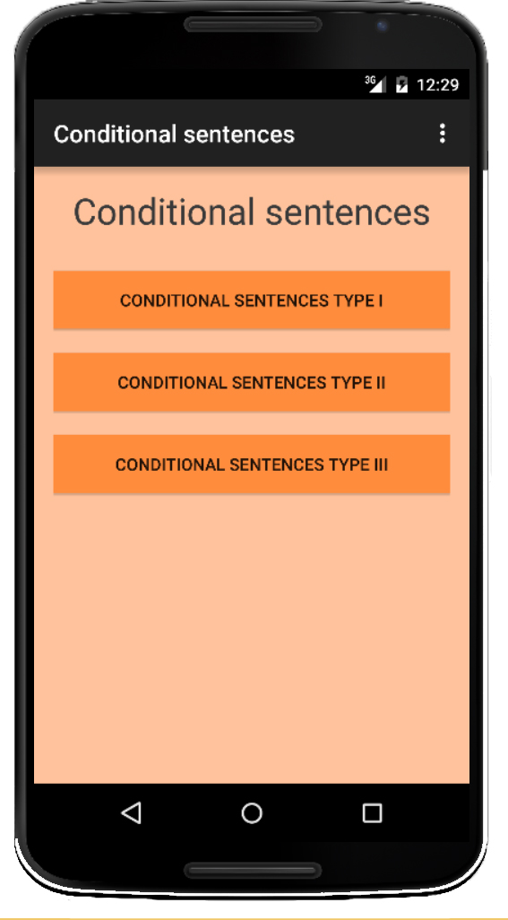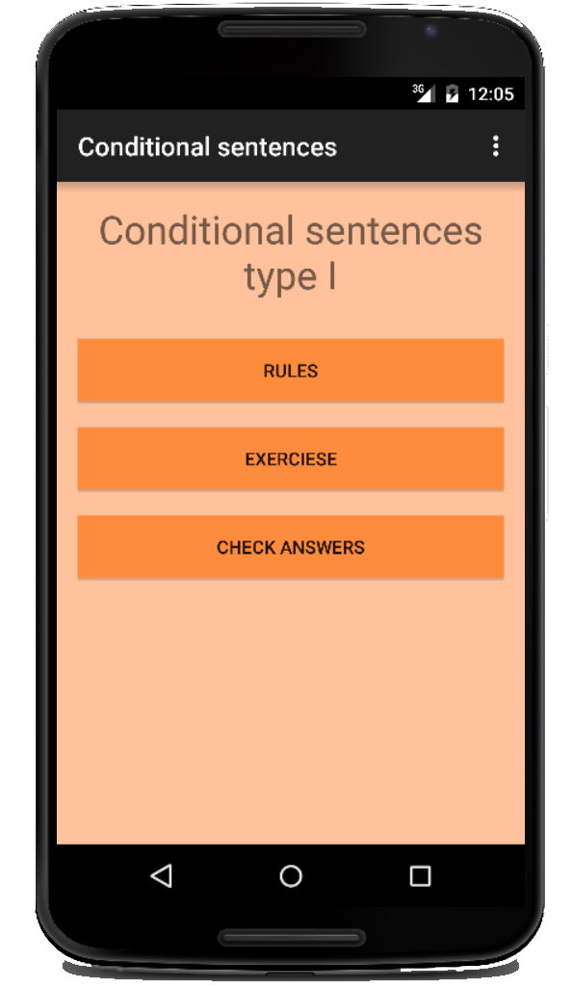

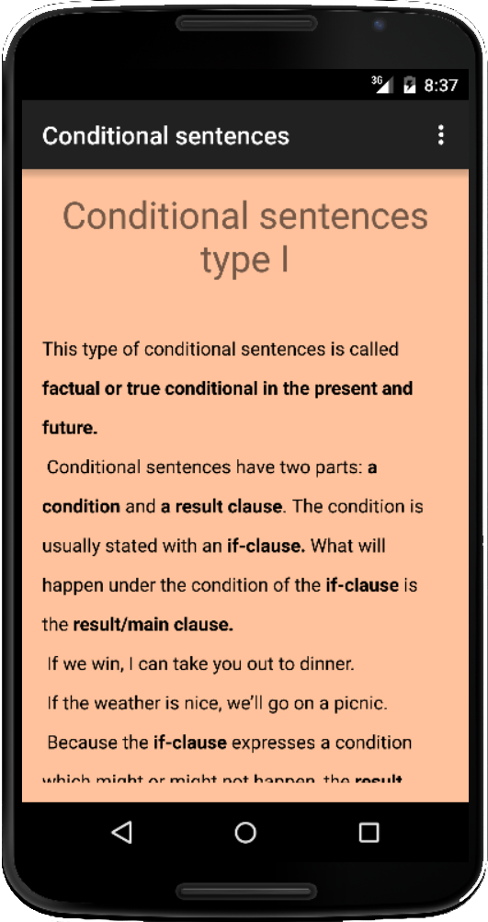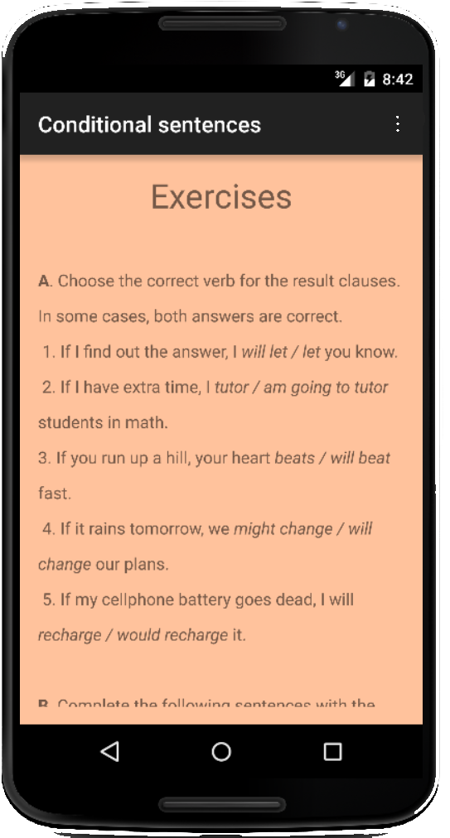

Validity of this app was evaluated by three experts in the filed with more than five years of teaching and testing experience. It has three parts: instruction of three types of conditional sentences, exercises, and answers. It should be noted that correct answers were available to students after they email their own answers to the teacher.

Appendix B
Pretest
Complete the sentences according to the basic rules for conditional sentences.

1. If we ………. him tomorrow, we’ll say Hello.
a . meet b. will meet c. met d. had met

2. He would have repaired the car himself if he ………. the tools.
a. will have b. had c. had had d. would have

3. If you drop the vase, it ………. .
a. breaks b. broke c. will break d. had broken

4. If I ………. Stronger, I’d help you carry the piano.
a. am b. will be c. were d. had been

5. If we’d seen you, we………. .
a. stop b. would have stopped c. stopped d. had stopped

6. If my brother were here, he ………. What to do.
a. has known b. will know c. would know d. know

7. He would go mad if he ………. that.
a. hears b. would hear c. has hear d. heard

8. If he told the truth, they ………. him.
a. were forgiving b. would forgive c. had forgiven d. forgive

9. If the town had been built at a lower altitude, it ………. a lot warmer.
a. would have been b. is c. will have d. had been

10. If you bring it tonight, I ………. It for you.
a. will mend b. mended c. have mended d. will have mended

11. If he had treated her well, she ………. him.
a. will not leave b. would not have left c. does not leave d. had left

12. If they had not given him the money, the robber ………. them.
a. has shot b. had shot c. shoot d. would have shot

13. I ………. you now if I could.
a. help b. helped c. am helping d. would help

14. He ………. more crops if he had used modern farming method.
a. would have grown b. grew c. grew d. had grown

15. I ……… quiet if I were you.
a. shall keep b. should keep c. keep d. was keeping

16. I would show them the picture if they ………. busy.
a. don’t b. didn’t c .aren’t d.weren’t

17. If you don’t practice, you ……….. learn English.
a. can b. won’t c. will d. may

18. If I had worn a jacket, I ………. so cold at the park.
a. wouldn’t have been b. won’t be c. wasn’t d. had been

19. Sally would answer the phone if she ………. in her office right now.
a. was b. had been c. were d. is

20. If I have enough apples, I ………. an apple pie this afternoon.
a. baked b, will bake c. baking d. would bake

21. If Alex were a teacher, he would teach law. Choose the correct sentence.
a. Alex is a teacher. b. Alex is not a teacher.
c. Alex teaches law. d. Alex is not a teacher, but he teaches law.

22. She can’t come tomorrow. I wish she ………. tomorrow.
a. will come b. comes c. have come d. could come

23. If I ………. A bird, I wouldn’t want to live my whole life in a cage.
a. were b. am c. was d. be

24. Would you have left if you had had money?
a. yes, I would. b. yes, I have. c. yes, I would have d. yes, I would’ve.

25. What would you do if you ……… rich?
a. are b. had been c. were d. would be

26. I wish she ……… tomorrow.
a. will call b. would call c. call d. calls

27. If he …………. eat too much, he wouldn’t be so fat.
a. didn’t b. doesn’t c. wasn’t d. won’t

28. If you ……… German, you could translate this story for me.
a. know b. have known c. would know d. knew

29. If I have enough time, I ………. my parents an email every week.
a. will send b. am sending c. send d. had sent

30. If I had enough time, I ……….. my parents last night.
a. sent b. would have sent c. had sent d. was sending

MA student of TEFL, B-eli1990@yahoo.com; Department of English Language, Isfahan (Khorasgan) Branch, Islamic Azad University, Isfahan, Iran
Lecturer (Corresponding Author), elahesadeghi20@yahoo.com; Department of English Language, Isfahan (Khorasgan) Branch, Islamic Azad University, Isfahan, Iran

