**The Impact of Pre-task Planning Vs. On-line Planning on Writing Performance: A Test of Accuracy, Fluency, and Complexity**

[1]Hamid Reza Kargozari

[2]Ali Nezami

IJEAP- 1905-1388

[3]Mohammad Reza Ebrahimi*

Received: 2019-05-25 Accepted: 2019-10-04 Published: 2019-10-10

**Abstract**

The aim of the current study was to compare the influence of on-line planning and pre-task planning on the performance of EFL university students enjoying different levels of proficiency regarding accuracy, fluency and complexity. To this end a group of 134 EFL learners with different proficiency levels were asked to write narrative tasks under two planning conditions (Pre-task planning and on-line planning). The results of the investigation showed that neither on-line nor pre-task planning affected the accuracy of writing. It was also revealed that on-line planning led to more fluent written language than what pre-task planning did, and that pre-task planning, compared to on-line planning, caused the students to produce more complex written language. Another finding of the research was that students with higher proficiency levels outperformed their low-proficiency counterparts considering accuracy, fluency and complexity during both on-line and pre-task planning. In other words, no interaction was found between planning conditions and proficiency levels.

***Keywords:*** Accuracy, Complexity, Fluency, Planning, Task Based Teaching

**1. Introduction**

In second language classes, learners might not always demonstrate their full competence. Anderson (1993) asserts that this gap is attributed to human's limited processing capacity and to the failure at concurrently attending to numerous aspects of a task; hence, due attention will not be paid to both meaning and form. Consequently, one aspect of a task/activity is prioritized (Skehan 1996; Van Patten 1990). Limited capacity problem could be solved by some solutions (e.g. Ellis 2005; Samuda 2001; Skehan 1996, 1998). Newell and Simon (1972) considered planning as a mental activity which is  
goal-oriented and is used by language users to attain pre-determined objectives. It has been assumed for a long time that task planning influences a performance in L1 and L2 writing.

Research on L1 writing has revealed that the main difference between novice and expert writers is linked to the time they spend for planning (Scardamalia & Beretier, 1987). Furthermore, the effect of planning as a tool to develop writing fluency, writing quality and language use has been supported in L2 writing (Kellogg 1987, 1988, 1990). Kellogg (1996) specifies three main systems underlying the writing process. These include *formulation, execution*, and *monitoring.* It is believed that each system imposes a varying degree of demands on working memory resources of the writer. Among these three systems, formulation places the greatest degree of demands on working memory. This system consists of two processes of *translation* and *planning* competing with each other for working memory. It is believed that task planning reduces the demands on working memory and as a result, additional capacity is provided for *translation* process.

Moreover, some second language acquisition (SLA) theories have supported the same influence. For example, Skehan's (1998) Limited Attentional Capacity Model and Robinson's (2001) Cognition Hypothesis has confirmed the positive effects of planning on L2 production. Furthermore, a large number of studies have investigated this effect on L2 production (e.g. Elder & Iwashita 2005; Ellis & Yuan 2004; Nakakubo, 2011).

**2. Planning Categorizations**

Ellis (2005) proposes two distinct planning types: pre-task planning and within-task planning (also known as on-line planning). The distinction is made based on the time of planning, either before the task itself or during the task performance. Pre-task planning happens prior to the execution of the main task, and it is further divided into strategic planning and rehearsal. Within-task planning, on the other hand, refers to what happens during the main task performance. This stage can be handled under two conditions: pressured (learners will do the task under a time limit) as well as unpressured (learners complete the task under no time constraint) (Figure 1).

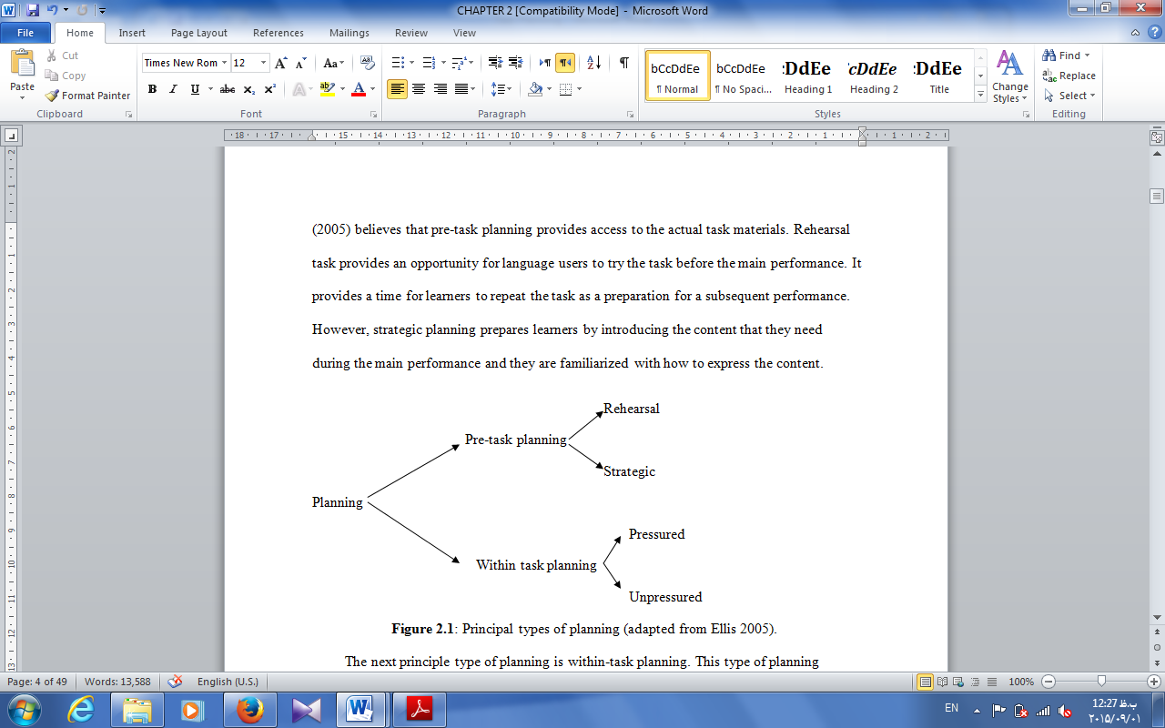

Figure1: Types of Task-based Planning (Adopted from Ellis, 2005, p. 4)

Before the main performance, language users are provided with an opportunity to accomplish the task by rehearsal or repetition; thus, learners can act out the task as groundwork for a following enactment. Nevertheless, students become acquainted with the language and content they require while performing by strategic planning.

Unpressured planning and pressured planning are done during a performance. Language learners are provided with sufficient, still limited, time for planning their output in pressured planning, but they, during unpressured planning, have the opportunity to engage in careful on-line planning. Pressured planning, nonetheless, provides no room for breathing space in planning at the time of performing the task (Bui, 2014). Ellis (2005) argues that pressured planning prepares learners of L2 with rapid planning.

Ellis (2009) slightly revised the previous categorization by proposing three types of planning: rehearsal, pre-task (strategic) planning and within-task planning. Bui (2014) believes these two categorizations (Ellis 2005, 2009) are the same and they rely heavily on external manipulations for task preparedness. He believes both rehearsal and pre-task planning prepare learners before a task performance. Bui (2014) adds "within-task planning can also be viewed as being something that can be increased or decreased so as to vary the readiness for performance in a series of consecutive segments of strategic planning, carried out *ad hoc* during a task (original emphasis)” (p.65).

A recent classification was suggested by Bui (2014). He extended the construct of planning by proposing the term *task readiness.* In his point of view, task readiness consists of two macro-dimensions (Table 1). These include *task-internal* *readiness* or implicit planning and *task-external readiness* or explicit planning. The former is a novel part broken down into topic familiarity, schematic familiarity, task familiarity, and task repetition. The latter is identical to Ellis’s categorization (2009): rehearsal, strategic planning and within-task planning. Bui (2014) believes that "the major diﬀerence between task-internal and task-external readiness is the degree of naturalness, or rather the degree of *ad hoc* manipulation, of the task preparation" (P. 67).

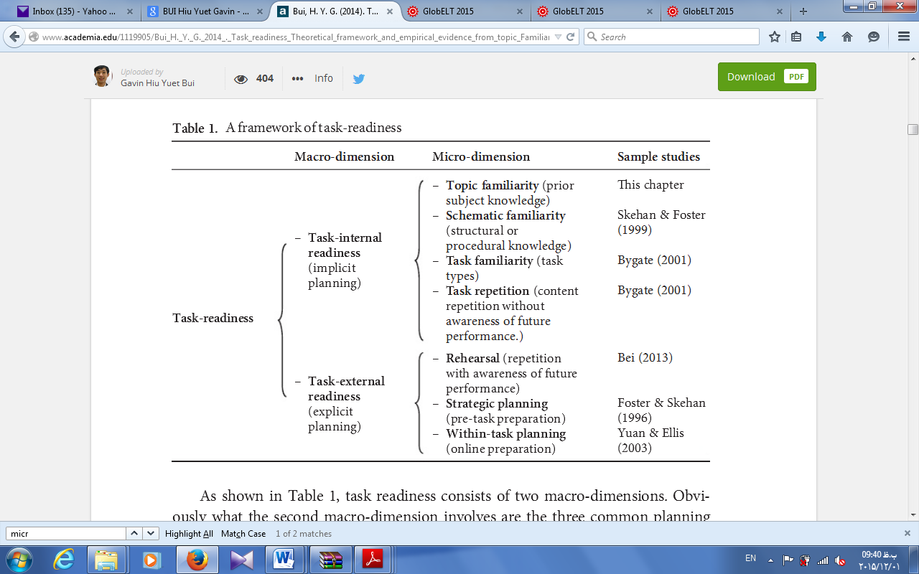

Figure 2: A Framework of Task-readiness (Adopted from Bui, 2014, p. 66)

**3. Literature Review**

Many researchers have investigated the effects of different types of planning time on L2 learners’ written task performance in terms of accuracy, fluency, and complexity (Foster & Skehan 1996; Ortega 1999; Ellis & Yuan, 2004; Sangarun 2005; Shin 2006; Tavakoli & Skehan 2005; Rahimpour & Nariman-Jahan 2011). Soleimani and Kargozari (2014) provide a comprehensive report of research findings done in written task planning. One of the earliest investigations in written task planning was done by Ellis (1987). He studied the impact of task planning on the accuracy of both written and spoken performance. He studied 17 English as Second Language (ESL) learners and found a positive correlation between planning and grammatical accuracy.

Wigglesworth (1997) studied the combination effects of planning time, task types and proficiency levels under a test situation. Wigglesworth’s results revealed that both task type and proficiency level contributed to the effect of planning on accuracy. High proficiency group benefited more by the presence of planning time on more complex tasks than low proficiency group in terms of accuracy. On the other hand, low proficiency group did not take the advantage of planning time. In their study, Ellis and Yuan (2004) investigated the effects of three types of planning including no planning, pre-task planning and on-line planning on the performance of 42 Chinese learners' narrative writing. They found that pre-task planning resulted in greater fluency and syntactic variety, on-line planning resulted in greater accuracy while no-planning condition had no effect on fluency, complexity and accuracy.

Shin (2008) examined the impacts of planning conditions, task types and proficiency level on the performance of 157 Korean EFL learners' written performance. Tasks selected for the study were expository and argumentative tasks. The participants of the study in low group and high group of proficiency had to perform the tasks under individual and collaborative conditions. The results of the study showed that the participants in the collaborative group outperformed only in expository task than individual group. Moreover, the researcher found that high proficiency group performed better than the low proficiency group in both tasks. Consequently, she concluded that written task performance was influenced by both planning conditions and proficiency levels. In 2012, Salimi, Alaviani and Hosseini explored the effects of strategic planning and task complexity on the accuracy of EFL learners' written performance. The participants of the study were 50 Iranian EFL learners who were asked to complete two simple and complex versions of a task under strategic condition. The results of the study showed that strategic planning led to more accuracy on both simple and complex tasks.

Salimi and Fatollahnejad (2012) investigated the combination of both strategic planning and task familiarity. They recruited 80 female Iranian EFL learners and assigned them into four groups of 20 members. The participants of the first group were asked to write about a familiar topic, Norouz, Iranian New Year. They had 10 minutes to plan their ideas before performing the task. The participants of the second group were asked to write the same familiar topic but without any planning time. However, the participants of the third group were to write about an unfamiliar topic, Charismas. They had 10 minutes to plan before starting the main task, exactly the same time for the first group. The participants of the fourth group were asked to write about the same unfamiliar topic without any planning time. The findings showed that strategic planning time increased both fluency and complexity but not accuracy. However, topic familiarity only helps the learners to use more complex structures.

Haghverdi, Biria and Khalaji (2013) studied the effects of task planning on the accuracy of narrative writing. The measure of accuracy was considered error-free clauses. Participants of their study were 90 Iranian EFL learners. They were randomly assigned into three groups of no-planning, within-task planning and strategic planning groups. All groups were to write based on a narrative task including six-picture series. The results surprisingly revealed that participants in the strategic-planning group wrote more accurately than the participants of the other groups.

Considering the aspects mentioned above, the present study compares the effects of planning conditions on written narrative task performance in terms of accuracy, fluency and complexity across different proficiency levels. Based on this orientation, the current study seeks to address the following research questions:

**Research Question One:** Does the type of task planning (mention the types here in all the questions) have any influence on the writing accuracy of EFL learners across different proficiency levels?

**Research Question Two:** Does the type of task planning have any influence on the writing fluency of EFL learners across different proficiency levels?

**Research Question Three:** Does the type of task planning have any influence on the complexity of EFL learners’ writing across different proficiency levels?

**4. Methodology**

*4.1. Participants and Setting*

A sample of 134 Iranian EFL learners at Tabaran Institute of Higher Education and Islamic Azad University Mashhad Branch, and Torbat-e-Heidarieh Branch participated in the study. Proficiency level was an independent variable so MA and BA students participated in the study with different levels of proficiency. The profile of the learners was as follows: the age range was 23 to 48 for 32 males and 102 females. For the purpose of measuring proficiency level, two sections of an unseen version of the TOEFL test (2004 edition) were administered. Learners who scored one standard deviation above and below the mean were respectively regarded as learners with high and low proficiency levels. 58 participants who scored one standard deviation above the mean were 'High-proficiency' group (HP), and 76 learners with minus one standard deviation below the mean made up the 'Low-proficiency' (LP) group of the study. The score of participants in low group was between 25 and 40 points out of 60 and the test scores in high group was between 46 and 58 points out of 60.

*4.2. Narrative Tasks*

To encourage narrative writing among learners, several researchers have tried cartoon pictures (e.g., Ellis & Yuan 2004; Ishhikawa 2006). Skehan and Foster (1997) consider narrative tasks as more cognitively demanding than some other tasks. Moreover, Kawauchi (2005) believe that the benefits of task planning are more apparent than other tasks. To avoid confusion and misinterpretation, tasks were clear and comprehensible. To this end two cartoon pictures were selected for the present study. Both of them were in black and white. The pictures were designed to indicate a story in chronological order of events. Therefore, they required interpretation on the part of the participants. Accompanied with a prompt, each picture provided learners with sufficient instruction to start writing.

The first narrative task called 'Dr. Krif' (adopted from Abdollahzadeh & Fard Kashani, 2011) was applied for on-line planning. The task consists of nine frames narrating the story of a doctor who wants to increase the number of his patients. Therefore, he decides to make some stone balls and locate them on different public places, hoping that people may kick them and have broken legs. The second narrative task applied for pre-task planning was another cartoon picture adopted from Heaton (1974). The cartoon consists of six pictures narrating a story about a boy called John. The same task has been used by other researchers in written narratives (Ellis 1987; Ellis & Yuan 2004; Piri et.al. 2012; Yuan 2001).

*4.3. Procedure*

Data collection took place in participants' usual classroom and during their class time.The participants of both high and low proficiency groups were given the same types of tasks, and they had similar planning conditions for completing the tasks. During pre-task planning condition, all the participants received the written instructions and explanation about the setting of the story, and about the application of planning condition. Then, they received a set of pictures. All the participants had an opportunity to plan for the tasks prior to the task performance. They were required to plan what they would write during the main writing task on the papers given first. Meanwhile, assistance was provided if they had any questions about the content, vocabulary, or grammatical structures. After finishing the planning time, the notes were taken away. Ellis and Yuan (2004) believe "removing the notes {ensures} that the language elicited by all the tasks {is} produced within the specified time limit” (p.70). Then, the participants were given 15 minutes to write at least 200 words about the story on a blank sheet. Written instructions were given for on-line planning. No time was allotted for pre-task planning while there was no time limitation for on-line planning there.

**5. Results**

To investigate the research questions both descriptive statistics and two-way ANOVA were calculated. Descriptive statistics revealed that the mean of on-line group (M = 16.39, SE = .50) on the accuracy of narrative writing was higher than the mean of the pre-task group (M = 15.52, SE = .50) (Table 1).

|  |  |  |  |  |
| --- | --- | --- | --- | --- |
| Table 1: Descriptive Statistics, Narrative Writing Accuracy by Groups | | | | |
| Group | Mean | Std. Error | 95% Confidence Interval | |
| Lower Bound | Upper Bound |
| Pre-task | 15.520 | .505 | 14.525 | 16.514 |
| On-line | 16.390 | .507 | 15.392 | 17.387 |

The results of two-way ANOVA (F (1, 263) = 118.24, P < .05, Partial η2 = .31 representing a large effect size, observed power = 1 > .80) indicated that there was a significant difference between the low and high proficiency groups’ means on the accuracy of narrative writing (Table 2).

Table 2: Tests of Between-Subjects Effects, Narrative Writing Accuracy by Groups and Proficiency Level

|  |  |  |  |  |  |  |  |
| --- | --- | --- | --- | --- | --- | --- | --- |
| Source | Type III Sum of Squares | DF | Mean Square | F | Sig. | Partial Eta Squared | Observed Power |
| Group | 49.645 | 1 | 49.645 | 1.479 | .225 | .006 | .228 |
| Prof | 3969.635 | 1 | 3969.635 | 118.242 | .000 | .310 | 1.000 |
| Group * Prof | 15.162 | 1 | 15.162 | .452 | .502 | .002 | .103 |
| Error | 8829.460 | 263 | 33.572 |  |  |  |  |
| Total | 76545.458 | 267 |  |  |  |  |  |

The table illustrates that high proficiency group outperformed the low proficiency group on the accuracy of narrative writing. However, there was not any significant interaction between the types of planning and proficiency levels (F (1, 263) = .45, P > .05, Partial η2 = .002 representing a weak effect size, observed power = .10 < .80).

The second two-way ANOVA was run to probe the effect of pre-task and on-line planning on the narrative writing of the students in terms of fluency across different proficiency levels. The on-line group (M = 11.56, SE = .20) demonstrated a slightly higher mean on the fluency of narrative writing than the pre-task group (M = 10.11, SE = .20) (Table 3).

|  |  |  |  |  |
| --- | --- | --- | --- | --- |
| Table 3: Descriptive Statistics, Narrative Writing Fluency by Groups | | | | |
| Group | Mean | Std. Error | 95% Confidence Interval | |
| Lower Bound | Upper Bound |
| Pre-task | 10.113 | .202 | 9.716 | 10.511 |
| On-line | 11.561 | .202 | 11.162 | 11.959 |

There was a significant difference between the pre-task and on-line groups’ means on the fluency of narrative writing (F (1, 263) = 25.63, P < .01, Partial η2 = .089 representing a moderate to large effect size, observed power = .99 > .80) (Table 4).

Table 4: Tests of Between-Subjects Effects, Narrative Writing Fluency by Groups and Proficiency Level

|  |  |  |  |  |  |  |  |
| --- | --- | --- | --- | --- | --- | --- | --- |
| Source | Type III Sum of Squares | Df | Mean Square | F | Sig. | Partial Eta Squared | Observed Power |
| Group | 137.415 | 1 | 137.415 | 25.638 | .000 | .089 | .999 |
| Prof | 364.562 | 1 | 364.562 | 68.018 | .000 | .205 | 1.000 |
| Group * Prof | 8.433 | 1 | 8.433 | 1.573 | .211 | .006 | .239 |
| Error | 1409.633 | 263 | 5.360 |  |  |  |  |
| Total | 32371.825 | 267 |  |  |  |  |  |

Based on the results displayed in Table 4 (F (1, 263) = 68.01, P < .01, Partial η2 = .20 representing a large effect size, observed power = 1 > .80), there is a significant difference between the low and high proficiency groups’ means on the fluency of narrative writing. The high proficiency group outperformed the low proficiency group on the fluency of narrative writing. However, there was not any significant interaction between the types of treatment and proficiency levels (F (1, 263) = 1.57, P > .01, Partial η2 = .006 representing a weak effect size, observed power = .23 < .80). To investigate the third question of the study, descriptive statistics was calculated (Table 5).

|  |  |  |  |  |
| --- | --- | --- | --- | --- |
| Table 5: Descriptive Statistics, Narrative Writing Complexity by Groups | | | | |
| Group | Mean | Std. Error | 95% Confidence Interval | |
| Lower Bound | Upper Bound |
| Pre-task | 14.742 | .184 | 14.378 | 15.105 |
| On-line | 13.433 | .185 | 13.069 | 13.798 |

The table shows that the pre-task group (M = 14.74, SE = .18) outperformed the on-line group (M = 13.43, SE = .18) on the complexity of narrative writing. The effect of pre-task and on-line planning on the complexity of narrative writing of high and low proficiency groups was investigated through two-way ANOVA. The difference observed between the two means was statistically significant (F (1, 263) = 25.08, P < .01, Partial η2 = .087 representing a moderate to large effect size, observed power = .99 > .80) (Table 6). The table reveals no significant interaction between the types of planning and proficiency levels (F (1, 263) = .16, P > .01, Partial η2 = .001 representing a weak effect size, observed power = .069 < .80).

Table 6: Tests of Between-Subjects Effects, Narrative Writing Complexity by Groups and Proficiency Level

|  |  |  |  |  |  |  |  |
| --- | --- | --- | --- | --- | --- | --- | --- |
| Source | Type III Sum of Squares | df | Mean Square | F | Sig. | Partial Eta Squared | Observed Power |
| Group | 112.251 | 1 | 112.251 | 25.089 | .000 | .087 | .999 |
| Prof | 176.932 | 1 | 176.932 | 39.546 | .000 | .131 | 1.000 |
| Group * Prof | .732 | 1 | .732 | .164 | .686 | .001 | .069 |
| Error | 1176.687 | 263 | 4.474 |  |  |  |  |
| Total | 53663.777 | 267 |  |  |  |  |  |

**6. Discussion**

The results emerging from this study indicated that the use of either type of pre-taskplanning or on-line planning cannot improve the accuracy of the participants' writing. The results also revealed that high proficiency group outperformed low proficiency group in terms of accuracy. Moreover, our findings showed that there was no interaction between planning conditions and proficiency levels in term of accuracy in narrative tasks, confirming the results of similar studies in the literature. For instance, the findings of present study converge the findings of Bygate’s (2001) study, examining the effects of rehearsal planning on CAF components of L2 learners’ performance for narrative task. The results of his study reported no development in accuracy of the second performance.Seyyedi, Mohamed Ismail, Orang, and Sharafi Nejad (2013) also found that pre-task planning time had no effect on the accuracy of the learners' narrative writing. Ellis (2009) believes that accuracy like other aspects of performance are constituents of language proficiency. It is assumed that a proficient language user will be able to perform tasks more accurately, and fluently with more use of complex structures. The findings of the present study confirm Ellis' claim in terms of accuracy.

The results also revealed a significant difference between the performance of participants in  
 pre-task planning and on-line planning in terms of fluency. As a whole, participants produced more fluent narrative writing under on-line planning than pre-task planning condition. These results are supported by some studies, but disconfirmed by some others. In line with the findings of the present study, Skehan (1998) believes that as limited attentional capacity has an impact on task performance, it is not clear whether the learner, during the task, focuses on meaning for fluency or on form for accuracy and complexity. It seems that during on-line planning attention is more on meaning than form, but during pre-task planning learners pay more attention to form (Ortega 1999). This fact may interpret the greater fluency during on-line planning in the present study. Skehan and Foster (2001) also believe that when the focus is on form, there is a competition between accuracy and fluency. Mochizuki and Ortega (2008) also reported no improvement in fluency of pre-task planning. Mehrang and Rahimpour (2010) also confirm this result and believe that pre-task planning has no effect on the fluency of narrative writing. Moreover, Mohammadzadeh Mohammadabadi, Dabaghi, and Tavako (2012) could not find any effect of pre-task planning on the fluency of narrative task.

In term of complexity, the findings of the study showed that the pre-task group outperformed the on-line group. It was also proved that the high proficiency participants had a better performance than the low proficiency group on the complexity of narrative writing, similar to what they demonstrated in the accuracy and fluency of their writing. Moreover, no interaction was found between the types of treatment and proficiency levels. Wigglesworth (1997) claims planning time may allow high proficiency learners to produce more complex language, but low proficiency learners take no advantage of planning time. Shin (2008) also claims there is no interaction between the type of planning and proficiency level in complexity of narrative tasks. He claims proficiency effect is consistently over different writings. These findings are compatible with Mehrang and Rahimpour (2010) as well. They reported that that pre-task planning leads to more complexity of narrative tasks. Another study done by Meraji (2011) confirms this result that pre-task planning fosters complexity of narrative tasks. Another study which is in agreement with the present findings is Seyyedi et. al*.* (2013). They concluded that pre-task planning had a significant effect on the complexity of narrative tasks among their Iranian EFL learners.

**7. Conclusion and Implications**

All in all, neither pre-task nor online planning influenced the accuracy of writing in the current investigation, but for fluency on-line planning was more influential than pre-task planning, yet pre-task planning brings about more complex structures. Based on the findings, we would suggest that it would be helpful if students are given time to plan their ideas in advance of the writing task; therefore, they would be able to produce more complex structures. While more proficient learners in the current study could outperform others, it seems that working more on pre-task planning for the purpose of increasing proficiency would be a redeeming work.

**References**

Abdollahzadeh, S., A. & Fard Kashani. (2011). The effect of task complexity on EFL learners' narrative writing task performance. *Journal of English Language Teaching and Learning*. *3*(8), 1-28.

Anderson, J.R. (1993). *Rules of the mind*. Hillsdale NJ: Lawrence Erlbaum.

Bui, H. Y. G. (2014). Task readiness: Theoretical framework and empirical evidence from topic Familiarity, strategic Planning, and proficiency levels. In P. Skehan (Ed.), *Processing Perspectives on Task Performance* (pp. 63-94). Amsterdam: John Benjamins.

Bygate, M. (2001). Effects of task repetition on the structure and control of oral language. In M. Bygate, P. Skehan, & M. Swain (Eds.), *Researching pedagogic tasks: Second language learning, teaching and testing* (pp. 23−48). Harlow, England: Longman.

Elder, C., & Iwashita, N. (2005). Planning for test performance: Does it make a difference? In R. Ellis (Ed.), *Planning and task performance in a second language* (pp. 219-238). Philadelphia: John Benjamins.

Ellis, R. (1987). Interlanguage variability in narrative discourse: Styles shifting in the use of past tense. *Studies in Second Language Acquisition*, *9*(1), 1-20.

Ellis, R. (2005). *Planning and task performance in a second language*. Philadelphia: John Benjamins.

Ellis, R. (2009). The differential effects of three types of task planning on the fluency, complexity, and accuracy in L2 oral production. *Applied Linguistics*, 30, 474-509.

Ellis, R. & Yuan, F. (2004). ‘The effects of planning on fluency, complexity, and accuracy in second language narrative writing’. *Studies in Second Language Acquisition*, *26*(1), 59-84.

Haghverdi, H., R., Biria, R., & Khalaji, H., R. (2013). The Impact of Task-planning and Gender on the Accuracy of Narrations Composed by Iranian EFL Learners. *Journal of Language Teaching and Research*, *4*(1), 74-83.

Heaton, J. (1975). *Beginning composition through pictures*. London: Longman.

Ishikawa, T. (2006). ‘The Effect of Manipulating Task Complexity Along the [+/– Here-and-Now] Dimension on L2 Written Narrative Discourse’. In M.P. García Mayo (ed.), *Investigating Tasks in Formal Language Learning*. Clevedon: Multilingual Matters, 136-156.

Kawauchi, C. (2005). ‘The effects of strategic planning on the oral narratives of learners with low and high intermediate L2 proficiency’. In R. Ellis (ed.), *Planning and Task Performance in a Second Language* (pp.143-164). Philadelphia: John Benjamins.

Kellogg, R.T. (1987). Writing performance: Effects of cognitive strategies. *Written Communication, 4*(3), 269-298.

Kellogg, R.T. (1988). Attentional overload and writing performance: Effects of rough draft and outline strategies. *Journal of Experimental Psychology*, *14*(2), 355-365.

Kellogg, R.T. (1990). Effectiveness of prewriting strategies as a function of task demands. *American Journal of Psychology*, *10*(3), 327-342.

Mehrang, F. & Rahimpour, M. (2010). The impact of task structure and planning conditions on oral performance of EFL learners. *Procedia Social and Behavioral Sciences: World Conference on Educational Sciences*, 2010, Istanbul, Turkey.

Meraji, S.R. (2011). Planning Time, Strategy Use, and Written Task Production in a Pedagogic vs. a Testing Context. *Journal of Language Teaching and Research*, *2*(2), 338-352.

Mochizuki, N. & Ortega, L. (2008). Balancing communication and grammar in beginning level foreign language classrooms: A study of guided planning and relativization. *Language Teaching Research*, *12*(1), 11-37, doi:10.1177/1362168807084492.

Mohammadzadeh Mohammadabadi, A.R., Dabaghi, A., Tavakoli, M. (2013). The effects of simultaneous use of pre-planning along Here-and-Now dimension on fluency, complexity, and accuracy of Iranian EFL learners’ written performance. International Journal of Research Studies in Language Learning, *2*(3), 49-65.

Newell, A. & Simon, H. (1972). *Human Problem Solving*. Englewood Cliffs, NJ: Prentice Hall.

Nakakubo, T. (2011). The effects of planning on second language oral performance in Japanese: Processes and production. *Unpublished doctoral dissertation*, University of Iowa.

Ortega, L. (1999). Planning and focus on form in L2 oral performance. *Studies in Second Language Acquisition,* *21*(1), 109-48.

Piri, F., Barati, H., & Ketabi, S. (2012). The Effects of Pre-task, On-line, and both Pre-task and On-line Planning on Fluency, Complexity, and Accuracy – The Case of Iranian EFL Learners’ Written Production. *English Language Teaching*, *5*(6), 158-167.

Rahimpour, M., & Nariman-Jahan, R. (2011). The Effects of Planning on Writing Narrative Task Performance with Low and High EFL Proficiency. *English Language Teaching*, *4*(1), 120-127.

Robinson, P. (2001). *Cognition and Second Language Instruction*. Cambridge: Cambridge University Press.

Salimi, A., Alaviani, P., Hosseini, P., & Shafaei, A. (2012). The Impact of Task Complexity and Strategic Planning Time on EFL Learners’ Accuracy and Fluency in Written Task Production. *International Journal of Applied Linguistics and English Literature*, *1*(7)104-116.

Salimi, A. & Fatollahnejad, S. (2012). The effects of strategic planning and topic familiarity on Iranian intermediate EFL learners’ written performance in TBLT. *Theory and Practice in Language Studies*, *11*(2), 2308-2315.

Samuda, V. (2001). Guiding relationships between form and meaning during task performance: The role of the teacher. In M. Bygate, P. Skehan, & M. Swain (Eds.), Researching *pedagogic tasks: Second language learning, teaching and testing* (pp. 119-141). New York: Longman.

Sangarun, J. (2005). The effects of focusing on meaning and form in strategic planning. In R. Ellis (Ed.), *Planning and task performance in a second language* (pp. 111−141). Philadelphia: John Benjamins.

Scardamalia, M. & Bereiter, C. (1987). Knowledge telling and knowledge transforming in written composition. In S. Rosenberg (Ed.), *Advances in Applied Psycholinguistics, Reading, Writing and Language Learning*. 2: (pp. 142-175). Cambridge: Cambridge University Press.

Seyyedi, K., Mohamed Ismail, Sh., A., Orang, M., & Sharafi Nejad, M. (2013). The effect of pre-task planning time on L2 learners' narrative writing performance. *English Language Teaching*, *6*(12), 1-10.

Shin, Y. (2008). The effects of planning on L2 writing: a study of Korean learners of English as a foreign language. (Unpublished PhD Dissertation), University of Iowa, United States.

Skehan, P. (1996). A Framework for the Implementation of Task-based Instruction. *Applied Linguistics* *17*(1), 38-62.

Skehan, P. (1998). *A Cognitive Approach to Language Learning*. Oxford, England: Oxford University Press.

Skehan, P., & Foster, P. (1997). Task type and task processing conditions as influence on foreign language performance. *Language Teaching Research*, *1*(3), 185−211.

Skehan, P., & Foster, P. (2001). Cognition and tasks. In P. Robinson (Ed.), *Cognition and second language instruction* (pp. 183-205). New York: Cambridge University Press.

Soleimani, H., Kargozari, H. R. (2014). Uncovering new trends of investigation in writing task planning. *International Journal of Asian Social Science*, *4*(9), 991-1002.

Tavakoli, p. & Skehan, P. (2005). Strategic planning, task structure, and performance testing. In R. Ellis (Ed.), *Planning and task performance in a second language* (pp. 239–277). Amsterdam: Benjamins.

VanPatten, B. (1990). Attending to form and content in the input: An experiment in consciousness. *Studies in Second Language Acquisition*, *12*(3), 287-301.

Wigglesworth, G. (1997). An investigation of planning time and proficiency level on oral test discourse. *Language Testing*, *14*(1), 85-106.

Yuan, F. (2001). *The effects of planning on language production in task-based language teaching.* (Unpublished Doctoral Dissertation), Temple University, United States.

1. Lecturer, [hamidrezakargozari@yahoo.com](mailto:hamidrezakargozari@yahoo.com); Tabaran Institute of Higher Education, Department of English Language, Mashhad, Iran.
2. Academic Writing Instructor, [ali.nezami@ozyegin.edu.tr](mailto:ali.nezami@ozyegin.edu.tr); School of Languages (Undergraduate Program), Özyeğin University, Istanbul, Turkey.
3. Assistant Professor (Corresponding Author), [rezaebrahimi2@yahoo.com](mailto:rezaebrahimi2@yahoo.com); Department of English Language, Gonabad University, Gonabad, Iran.