The Effects of Multimodality on Reading Comprehension and Vocabulary Retention among Iranian EFL Learners
Nahid Naderi Anari
Ali Asghar Rostami Abusaeedi*
IJEAP-1910-1443
Mohammad Shariati
Received: 2019-10-05 Accepted: 2019-11-31 Published: 2019-12-01
Abstract
The studies that have investigated the effects of multimodality on reading comprehension and vocabulary retention of EFL learners in the context of Iran through mixed methodology are very limited. Accordingly, this two-phase study aimed to investigate the effect multimodalities might have on reading comprehension and vocabulary retention of Iranian EFL learners. To this end, the first phase of the study included a sample of 30 male EFL learners selected through intact group sampling who were homogenized by using an OPT (Oxford Placement Test). Then they divided into experimental and control groups randomly. Passages used for experimental group were accompanied by visual images, videos, and audio tracks, while passages used for control group were the same texts without any of these. For conducting the second phase of the study, in the control group the teacher introduced the new vocabularies of each text only by their L2 definition but in the experimental group the teacher used L2 definition and image for introducing the new vocabularies. In the qualitative part of the study, an open-ended questionnaire and interview were used. By comparing pre-tests and post-tests using MANCOVA, the results showed the effectiveness of using multimodality in L2 reading classrooms and vocabulary retention of EFL learners. The analysis of the results obtained from the qualitative phase revealed that learners preferred texts to be accompanied by visual images.
Keywords: EFL Learners, Reading Comprehension, Vocabulary Retention, Multimodality
1. Introduction
Today, more than ever before, attention is being given to the role of the multimodality and new literacies as those must be followed and analyzed in English classrooms and operated inside 21st century literacies. The New London Group authors propose that there are six style components within the meaning-making process: Linguistic Meaning, Audio Meaning, Visual Meaning, Spatial Meaning, Gestural Meaning, and Multimodal meaning. That Multimodal meaning refers to the manner the primary five modes relate to each other. Therefore, each one of those style components are observed as a ‘mode’ by the authors. Moreover, the presentation of new media and the immediate needs of today’s EFL learners demands educational situations to restructure and change. Specially, paradigmatic shift is looked for in the area of literacy education that the growing emergence of technologies has provided challenge on practices and theories in ‘multimodality’ – a term that refers to the practice of meaning-making including the determined combination of semiotic sources involving, speech, writing, photos, gestures, sound, and drawing (Emmison & Smith, 2000; Kress, 2003; The New London Group, 1996; Van Leeuwen & Jewitt, 2001). In this definition it is significant to consider the difference between ‘medium’ and ‘mode’. Nelson (2006) mentioned that these words usually get confused. Medium means the way that technology gets presented, for example through a CD-ROM or computer application, printed book, whereas mode means print, sound, gesture, color and other types of making meaning.
Although many studies have investigated the closed connection between multimodality and multiliteracies in the current instructional settings (Serafini, 2011; Sewell & Denton, 2011; Unsworth, 2001; Walsh, 2010), or the link between multimodality and foreign languages (Farias, Obilinovic & Orrego, 2011; Lamy, 2007), rarely any previous research has emphasized on the role of multimodality in reading comprehension, and vocabulary retention of a foreign language. Even if such has been the case, the emphasis has been more on university students than on EFL learners. Therefore, the present study aims at making contribution to this field by examining the multimodal texts and their effect on reading comprehension skills and vocabulary retention of Iranian EFL learners. Also many years, as a result of not paying attention to this significance, there was little or no emphasis on vocabulary instruction. It was thought that L2 learners could learn all the vocabularies they require without the aid of their instructors. Today, researchers spend more time to work on a number of strategies and techniques for teaching vocabulary (e.g. Mizumoto & Kansai, 2009; Hummel, 2010; Shen, 2010).
2. Literature Review
Much research has been done on the extensive reading of printed or linear text. Research findings related to learning English as a foreign/second language support the notion that extensive reading facilitates the development of English proficiency (e.g., Asraf & Ahmad, 2003; Bell, 2001; Mason & Krashen, 1997; Lao & Krashen, 2000). After the popularization of Information and Communication Technologies (ICT), among which the Internet being the most pervasive, studies on the interaction with multimodal text via ICT has contributed to the concept that having contact with multimodal text is essential to the development of English literacy in the 21st century. However, little investigation (e.g., Evans, 2005; Lankshear & Knobel, 2006) has been done concerning the effect of interacting with English multimodal text on English learners’ development of English proficiency.
According to Ramezanali (2017), vocabulary expansion is important for mastering a foreign language. There are different approaches for vocabulary teaching, involving glossing. The results of her study indicated that glossing was importantly more effective than nonglossing techniques for participants’ short-term retention in multiple-choice productive recognition tests and productive recall; and partly influential for their long-term retention. Moreover, in vocabulary assessments, L2 definition and video/animation glossing as well as L2 definition and audio glossing were more influential than L2 definition alone for most test sessions; but because L2 definition alone was also effective for few test sessions, the findings cannot be generalized mainly. The results of the interviews and questionnaire suggested that the participants preferred L2 definition and video/animation glossing more than the two other modes.
Given the important role of vocabulary knowledge in language improvement, the literature is full of researches that investigate the effects of different vocabulary learning strategies (Alghamdi, 2018). Considering two areas of research on vocabulary learning, digital gaming and multimodal glossing and reporting on an experimental research whose aim was to examine the impact of providing EFL learners (n=162) with three gloss conditions (L1 test + picture, L2 text + picture, and picture-only) when they play a video game based on their vocabulary learning and retention is done by Alghamdi (2018). The learners took two vocabulary tests immediately after playing the game, and again two weeks later in his study. The findings showed that while multimodal glossing was useful for all groups, the L1 text + picture gloss group significantly performed better than the other two groups in the learning and retention of the targeted words.
Reading is a vital element of language proficiency and a significant focus of second/foreign language teaching. Pellicer-Sanchez et. al (2018) exploited eye-tracking technology to find out children and adult second language (L2) learners’ processing of the various input sources within two multimodal reading conditions. Results of the study showed that children and adult L2 learners use more time reading the text than processing the pictures, regardless of the reading mode. The presence of auditory input in reading-while-listening conditions permit learners to use more time processing the pictures, but the processing differences observed between the two conditions do not appear to have an effect on reading comprehension.
Researches regarding presentation mode of vocabulary began in the 1960s. One of the key difficulties EFL learners face in vocabulary learning is the problem of vocabulary retention in which vocabularies are mainly forgotten in the first hours or days since learning or memorizing happens. Although various studies present the impacts of different modes of making meaning like print mode or visual mode (Zarei & Gujjar, 2012) on vocabulary retention, there is a lack of research on the relative effects of the combination of various modes in comparison with the use of one special mode (Aghaei & Gouglani, 2016). In Aghaei and Gouglani ' s study, the use of different modes of meaning-making, a combination of visual, linguistic, spatial, audio, and gestural communicative modes in the recent century in learning language skills and sub-skills have been considered as Multimodal Pedagogy that the experimental group got vocabulary presentation applying Multimodal Pedagogy. The control group followed the usual pedagogy based on the vocabularies ' library dictionary definition applying print-based instructional materials. The findings indicated that learners who were presented with a variety of modes of meaning making showed better long-term vocabulary retention.
To the best of researchers' knowledge, it appears that the studies that have examined the impacts of multimodality on reading comprehension and vocabulary retention of EFL learners in the context of Iran through mixed methodology are very limited. Furthermore, researches that have empirically examined the effects of multimodality on reading comprehension and vocabulary retention have reported mixed findings. Furthermore, on the basis of aforementioned facts, it can be claimed that there have been a number of studies conducted on the effect of multimodal texts on EFL learners’ learning processes. Few, however, examined the way various modes of a text are processed by readers and which special modes influence learners’ understanding the most. Accordingly, the present study aims to fill in these gaps by employing both quantitative and qualitative methods of data collection. To this end, the following research questions were proposed to be answered.
Research Question One: Can the use of multimodal texts lead to a higher standard of reading comprehension skills?
Research Question Two: Can the use of multimodal presentation enhance EFL learners' vocabulary retention?
Research Question Three: What are Iranian EFL learners' attitudes towards multimodality?
3. Method
3.1. Participants
For answering the research questions, a sample of 30 male EFL learners in two intact English classes from Razi English Institute in Anar, Iran was selected through intact group sampling. Although the learners in both classes were homogenized, in advance, through Interchange Placement Test and they were at the same level of proficiency (intermediate), the Oxford Placement Test (OPT 2007) was administered to all learners in both classes prior to the study to ensure that the learners with the intermediate level of proficiency were chosen. Based on their performance on the proficiency test, from among the 36 participants who were from two separate classes each with 18 learners and aged between 15 and 17, 30 students were selected. Two learners from one class and four learners from another class were not at intermediate level. They were randomly divided into three groups, control, experimental, and pilot group (C= 10, E= 10, P= 10). The Pilot group was only used for determining the reliability indexes of materials and tests used in the study. However, for the qualitative phase of the study and for answering the third research question, participants (n=10) were selected through purposive sampling among experimental group in the first phase of the study.
3.2. Materials and Instruments
3.2.1. Oxford Placement Test (OPT)
The Oxford Placement Test consisted of 50 multiple choice questions assessing students’ knowledge of key grammar and vocabulary, 5 graded multiple-choice reading questions, and an optional writing task assessing students’ ability to produce the language. This study used reading and language use parts of the OPT to select a group of intermediate-level EFL learners. The Kuder-Richardson (KR) 21 formula of OPT was estimated to be 0.898 through pilot group and content validity of the test was already proved. Geranpayeh (2006) argued that OPT, which is a standardized English proficiency test, has been pretested and validated by about 6,000 students in about 60 countries. According to Allan (2004), the developer of the test, OPT has been calibrated against the proficiency levels based on the Common European Framework of Reference for Languages (CEF), the Cambridge Examinations, and other major international examinations such as TOEFL. The cut-off points for proficiency levels set by Allan (2004) was considered by several researchers (e.g., Jabbari, 2014; Rebarber et al., 2007; Tahriri & Yamini, 2010) as reliable indicators that would signal language proficiency levels.
3.2.2. Reading Comprehension Pre-test and Post-test
The pre-test was also used as the post-test to avoid any inequality between them. The allotted time to answer both pre-test and post-test was the same, 35 minutes. The pre-test and post-test contained three reading passages including 15 items, each text with five questions in the form of multiple-choice questions, administered to the learners. The test was derived from Interchange 2 Third Edition Teacher's Edition (2005). The test was also given to some TEFL instructors, who provided feedback on the content of the test to remove the probable ambiguities. The necessary revisions were made by the researcher to improve the content validity of the test. The reliability coefficient of the test was calculated through pilot group by using a KR-21 formula (r = 0. 909).
3.2.3. Vocabulary Retention Pre-test and Post-test
A vocabulary pre-test consisting of 60 words, was administered prior to the treatment. Participants were required to provide the Persian equivalents of the words. All words were selected from the reading passages used in the classrooms. The duration of this test was 20 minutes. A vocabulary production post-test (the translation test) that was the same as the pre- test was administered to the learners in the final session. According to Saricoban (2012), translation has an integrating power on the language skills and one of the suggestible ways of testing language areas and skills of the students in the open-ended procedure is translation since "translation has a very pivotal role in foreign language teaching in transforming the receptive skills into productive ones" as is stated by Hismanoglu (1999). The test was given to some TEFL instructors and they confirmed its content validity and the reliability coefficient of the test was calculated through pilot group by using a KR-21 formula (r = 0.893).
3.2.4. Reading Passages
A total of 10 reading passages were also selected for teaching in the classrooms, seven reading sections from two different intermediate English textbooks were utilized: American English Files (2005) and New Total English (2006). Also three reading passages chosen from work book of Interchange 2 Third Edition were utilized because of the similarity that exists between these reading passages and the reading comprehension pre-test and post-test. The same text was taught in each group, but the first group or the control group received a traditional approach through using linear texts (without any images, audios, or videos) by the researcher. The second group received multimodal printed texts, accompanied by audio, image, and in some cases videos to be taught to the participants of experimental group.
3.2.5. Semi-structured Interview
A semi-structured interview was designed to determine the participants' attitudes towards and perceptions of multimodality. The questions are presented in the result section.
3.2.6. Open-ended Questionnaire
For the qualitative phase of the study, in order to elicit more detailed information from the participants and to cross-validate the data obtained from the semi-structured interview, an open-ended questionnaire was conducted by the researcher to determine the participants' attitudes towards and perceptions of multimodality. The questionnaire consisted of six questions, for which the participants wrote their responses in a few sentences in either English or Persian. They were asked to reflect on their overall perception about the treatment, such as whether they enjoyed the class, or which mode was more effective for their reading comprehension. Furthermore, some other related questions about multimodality were asked. The questions are presented in the result section.
Issues of reliability and validity of qualitative phase of the study regarding credibility, transferability, and dependability were checked. In order to check the credibility of the obtained data, member-checking, peer-debriefing and methods triangulation were used. For member-checking, the participants were asked to review the drafts and the themes emerging from the research to assess and garner the feedback about the accuracy of the interpretations. Peer-debriefing was involved an external check of the research by a colleague who was provided with the raw data and the researcher’s interpretations and explanations in order to review and ask questions about the research to ensure that the study makes sense and the interpretations from the data are plausible and accurate. For methods triangulation, two qualitative methods (open- ended questionnaire and interview) were used for enhancing the credibility of the study.
In order to investigate the transferability of the obtained data, thick and rich description was used. It is the researcher responsibility to provide sufficiently rich, detailed, thick descriptions of the context so that potential users can make the necessary comparisons and judgments about similarity and hence transferability. This is referred to as descriptive adequacy.
In order to assess the dependability of the obtained data, interrater method was used. The researcher randomly selected a transcript and asked a peer to code the transcript using the coding labels identified by the researcher. The second coder was free to add other codes she might identify. After the peer completed coding of the transcripts, the results were compared to the original coded transcript to determine whether both coders labeled components of the transcript the same.
3.3. Data Collection Procedure
To accomplish the purpose of the present study the following procedures were carried out. First, for the experimental phase of the study, the Oxford Placement test (OPT) test was administered to the participants to make sure that the participants of groups were at the same level of proficiency. Both control and experimental groups’ reading classes were taught by the researcher focusing on various reading-related activities and skills. The experimental group’s classes, however, were conducted somewhat differently due to the fact that the passages used for experimental group were accompanied by visual images, supplemental videos, and audio tracks. After each session, the participants answered the comprehension questions related to the given text. Finally, after 10 weeks the results of both groups were compared by using a reading test as posttest. It should be noted that the test was first piloted with some EFL learners and it was also used as pre-test. Then, to compare the progress of both groups after 10 weeks of instruction, a Multivariate Analysis of Covariance (MANCOVA) was used.
Further, for answering the second research question, a vocabulary pre-test consisting of 60 words, was administered prior to the treatment. Participants were required to provide the Persian equivalents of the words. All words were selected from the texts. The duration of this test was 20 minutes. In the control group the teacher introduced the new vocabularies of each text only by their L2 definition but in the experimental group the teacher used L2 definition and image for introducing the new vocabularies by PowerPoint. A vocabulary production post-test in the form of the pre- test was administered to the learners in the final session to assess their retention.
For the qualitative phase of the study, an open- ended questionnaire and a semi-structured interview schedule were designed by the researcher to determine the participants' attitudes and perceptions towards different modes of the text, their current study, multimodal texts, and English language proficiency. The interviewees were interviewed separately and the discussions were recorded for further transcription and analysis. They were free to answer the questions either in English or Persian. No time limit was set for the open- ended questionnaire or interviews.

3.4. Data Analysis Procedure
In order to answer the research questions, the gathered data were analyzed using MANCOVA to investigate the effect of multimodality on reading comprehension and vocabulary retention. Furthermore, a qualitative content analysis approach was used to analyze the data obtained. This process was involved several phases: First, the transcribed responses of the participants were carefully read to identify the meaningful data units based on the purpose of the study. The units were labeled through the concepts borrowed from the literature or the terms used by the participants themselves. These labels helped to identify the categories underlying the participants’ views, perspectives and experiences. In other words, the data that were collected through qualitative method, interview, were transcribed, identified, reduced, coded and categorized. The data were classified accordingly to descriptive codes such as perceptions about different modes of texts, the current course, multimodal texts as well as English language proficiency. Once coded, the data were analyzed for emerging categories.
Deductive approach was used for qualitative data analysis. It means the researcher used pre-determined codes and concepts that already exist within the aforementioned theories to confirm or evaluate these existing theories and to relate these sources of codes to the codes derived from the participants of the study.
4. Results
4.1. Descriptive Results
4.1.1. Statistical Description and Normality Indexes of Dependent Variables in Experimental and Control Groups
Mean and standard deviation of reading comprehension and vocabulary retention in pre-tests and post-tests are shown in table1. Also the normality index of variables is reported in the following table. The results of the table show that the mean and standard deviation of reading comprehension variable in experimental group in pre-test stage are (M=5.9, SD= 2.27) and in post-test stage are (M=50.2, SD=4.63). Also the mean and standard deviation of pre-test are (M=4.9, SD= 1.95), and post-test are (M=5.45, SD= 6.25) in control group.
In experimental group, concerning vocabulary retention variable, the mean and standard deviation of pre-test are (M=4.2, SD= 1.03), and post-test are (M=12.3, SD= 1.41). Also the mean and standard deviation of pre-test are (M=4.4, SD= 1.34), and post-test are (M=10.6, SD= 0.96) in control group. And normality indexes indicated that the variables are normal.
Table 1: Statistical Description and Normality Indexes of Participants' Scores
Group Variables Mean SD Shapiro-Wilk df sig.
Experimental RC pre-test 9.5 2.27 0.922 10 0.37
RC post-test 50.2 4.63 0.967 10 0.85
Control RC pre-test 9.4 1.95 0.887 10 0.15
RC post-test 45.5 6.25 0.909 10 0.27
Experimental VR pre-test 4.2 1.03 0.895 10 0.19
VR post-test 12.3 1.41 0.905 10 0.24
Control VR pre-test 4.4 1.34 0.896 10 0.19
VR post-test 10.6 0.96 0.904 10 0.24

4.1.2. Assumption of Homogeneity of Variance-covariance Matrices and Assumption of Linearity
Considering the homogeneity of variance-covariance matrices, Box's M index is not statistically significant (Box's M= 4.15, F (3.58320) =0.944, P=0.51). So, the assumption of homogeneity of covariance is established (Tabachnick & Fidell, 2007, p. 255). Besides, the assumption of linearity of relationship between reading comprehension and vocabulary retention in post-test is established (r_{xy}=0.69, p<0.01).
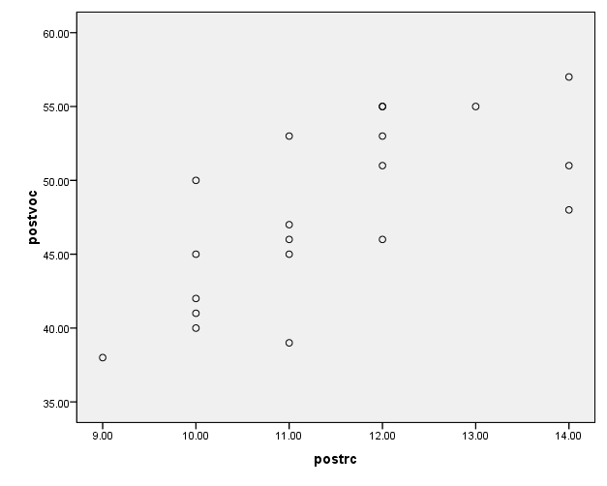
Figure1: Distribution between Dependent Variables in Experimental and Control Groups in Post-test
4.1.3. Assumption of Absence of Multicollinearity
Table 2 shows the amount of necessary correlation between dependent variables for next analysis base on Bartlett's test. As the table shows, the value of chi-square is statistically significant (x=15.13, p=0.019). So the assumption of absence of multicollinearity between dependent variables is rejected.
Table 2: Absence of Multicollinearity Between Dependent Variables
LR chi-square df sig.
-0.995 15.13 6 0.019

4.1.4. Assumption of Homogeneity of Error Variance between Groups
Table 3 shows reading comprehension post-test (F _{(1, 18)} = 0.887, p= 0.35) and vocabulary retention post-test (F _{(1, 18)} = 1.25, p=0.27), so the assumption of homogeneity of variance between groups is established.
Table 3: Assumption of Homogeneity of Error Variance Between Groups
Variable F Numerator df Denominator df sig.
Reading comprehension 0.887 1 18 0.35
Vocabulary retention 1.25 1 18 0.27

4.1.5. Assumption of Homogeneity of Linear Regression Slops
Table 4 shows the multivariable indexes of the assumption of linear regressions between dependent variables between groups. The results of the table show that linear combination of interaction between dependent variables and treatment is not significant, so the assumption of homogeneity of linear regression slops is established (Wilks' Lambda= 0.895, F _{(4, 26)} =0.36, p= 0.83). Also the results of step-down analysis of linear regression slops show that in reading comprehension (F _{(2, 14)} = 0.17, p= 0.84) and vocabulary retention (F _{(2, 13)} = 0.58, p= 0.57) the assumption of homogeneity of linear regression slops is established. The figures 4.2 and 4.3 show the assumption of linear regression slops.

Table 4: Assumption of Homogeneity of Linear Regression Slops Between Groups
Variation resources F Numerator df Denominator df Sig
Interaction between 0.17 2 14 0.84
RC Pre-test and treatment
Interaction between 0.58 2 13 0.57
VR Pre-test and treatment

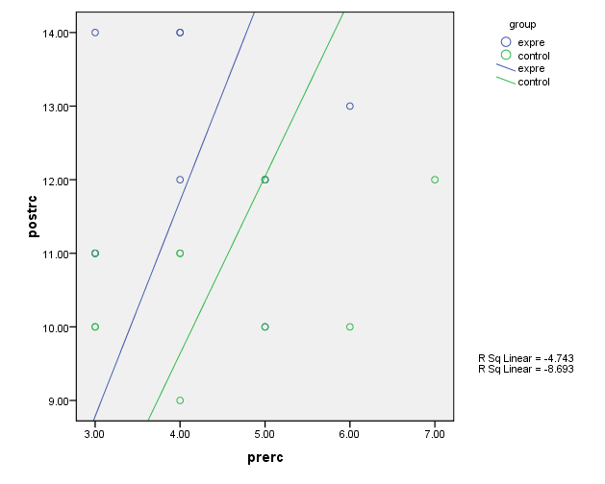
Figure 2: Homogeneity of Linear Regression Slops in Reading Comprehension

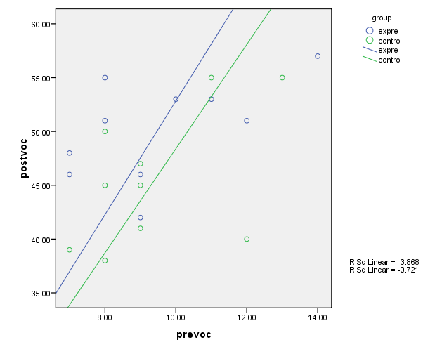Figure 3: Homogeneity of Linear Regression Slops in Vocabulary Retention
4.1.6. Significance of Treatment Effect
Table 5 shows that the treatment effect at least in one of the investigated variables is statistically significant. The results show that the treatment effect is significant (Wilks' Lambda=0.601, F _{(2, 15)} = 4.97, p= 0.022).
Table 5: Treatment Effect Significance
Variation resources Index Index value F-value df Mean squares Sig
Pillai's criterion 0.399 4.97 2 15 0.022
Wilks' lamb 0.601 4.97 2 15 0.022
treatment effect Hotelling's trace 0.663 4.97 2 15 0.022
Roy's greatest_ 0.663 4.97 2 15 0.022
characteristic root

4.2. Research Question One
Table 6 shows the results of covariance analysis within Mancova. The results show that the use of multimodal texts can lead to a higher standard of reading comprehension and it increases the participants' reading comprehension post-tests (F _{(1, 16) =} 5.29, p= 0.035, η2=0.249). Also the results show that 24.9 percent changes in participants' reading comprehension post-tests are considerable. Figure 4.9 shows the post-tests scores differences between two groups (experimental and control group).
Table 6: Covariance Analysis of Reading Comprehension within MANCOVA
Variation resources Sum square df Mean square F value Sig. Eta Squared
Reading comprehension 113.65 1 113.65 5.15 0.037 0.244 1 113.65
Pre-test
Group effect 116.62 1 116.62 5.29 0.035 0.249
(treatment effect)
Error 352.46 16 22.02
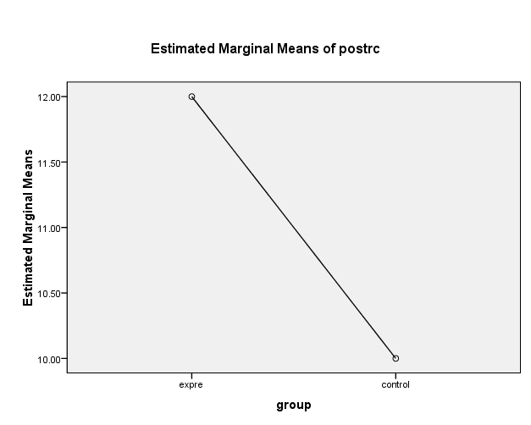
Figure 4: Differences of Reading Comprehension Post-test Corrected Means between Two Groups
4.3. Research Question Two
Table 7 shows the results of covariance analysis within Mancova. The results show that the use of multimodal presentation enhances EFL learners' vocabulary retention and it increases the participants' vocabulary retention post-tests (F _{(1, 16) = 10.06}, p= 0.006, η2=0.386). Also the results show that 38.6 percent changes in participants' vocabulary retention post-tests are considerable. Figure 4.10 shows the post-tests scores differences between two groups (experimental and control group).

Table 7: Covariance Analysis of Vocabulary Retention within MANCOVA
Variation resources Sum square df Mean square F value Sig. Eta Squared
vocabulary retention 0.197 1 0.197 0.139 0.71 0.009
Pre-test
Group effect 14.27 1 14.27 10.06 0.006 0.386
(Treatment effect)
Error 22.68 16 1.41
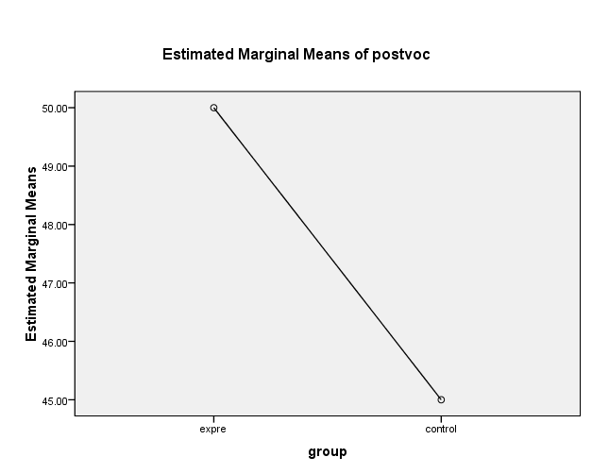
Figure 5: Differences of Vocabulary Retention Post-test Corrected Means between Two Groups
4.4. Research Question Three
The third research question asks about learners’ perceptions and attitudes towards each modality (image, video, and audio). Accordingly, to answer the third research question, the researcher provided the participants of experimental group with an open-ended questionnaire and interview so as to gauge their opinion and attitudes towards the effect of different modes of a given text on their reading comprehension proficiency. The interviewees were interviewed separately and the discussions were recorded for further transcription and analysis. They were free to answer the questions either in English or Persian. No time limit was set for the interviews.
The questions are categorized into the following themes: (a) effect of each mode on reading comprehension (b) individual’s familiarity with technology, (c) multimodal-texts use in learning, (d) expectations of current course and overall program. The interview and open-ended questionnaire consisted of six items and results are presented below according to each item included in the interview.
Which mode (image, video, audio…) is more effective for your reading comprehension?
Majority of participants expressed their favourable reactions to the different modes of a text such as visual images, videos, and audio recordings. Seven participants stated that visual images are more effective for their reading comprehension. Three participants stated that video is more effective, and only one participant expressed that audio is more effective for reading comprehension.
Do you use Technology for learning?
It seems from the participants' responses that multimodal texts and technology play an important role in their lives. All the participants stated that they used technology like television, computer, laptop, internet, as well as cell phone, but seven out of ten participants declared that they used technology for learning while three participants stated that they used technology not for learning but for getting general knowledge, communication, and entertainment.
Do multimodal texts help develop your English language knowledge?
All participants were affirmative. As one participant declared that "when we use radio or television, we can learn English, we can learn the way of speaking." Or another one, for instance, stated that "because most of the texts on the net are in English, when I refer to them while working on my assignment, I indirectly knew that it would improve my language proficiency".
Do you prefer learning with print texts or multimodal texts?
Ten of the participants revealed that they preferred multimodal texts to print texts. For instance, one learner disclosed that “at the moment we use lots of print texts, but we also need lots of multimodal texts apart from the books we use”. He added that multimodal texts involved all the information needed and they were easy to understand. The participants implied that it was easier to get information from multimodal texts compared to print. Another learner, for example claimed, “it is easy to get information”.
Do your instructors use multimodal texts in the classroom? If yes, what types of medium is used in your English classes?
Seven responded negatively while the rest were positive. Three participants claimed that their instructors used multimodal texts in the teaching and learning process. They stated that their instructors used laptop, CD, movies, internet, as well as power point slides in the classroom. The idea that may emerge from this discussion is that some of the instructors were using multimodal texts in the classroom while others were not. Some of the respondents found that instructors should employ multimodal texts as they were already a part of learners’ life worlds. However, it is clear that teaching styles also contributed to whether learners found the class interesting. Although, some instructors did not use multimodal texts, learners still found the lessons interesting. It is possible too that instructors’ preference of text-type ultimately influence the choice of text employed in the teaching and learning process.
5. Discussion
According to the findings of the present study, the use of multimodal texts has a significant influence on Iranian intermediate learners' reading comprehension achievement. Applying multimodal texts produced more happiness and act as motivating factor among the EFL learners who applied multimodal texts. The role of the instructors should not be ignored here. Improving a learner's reading comprehension ability needs language instructors to identify the key factors that affects the reader’s comprehension ability. Another benefit of reading multimodal texts is that learners would slowly become extensive readers simply since working with various modes of a given passage would increase learners’ motivation towards reading (Healey, 1999).
The findings of the primary stage of the study contradict what researchers like Macedo-Rouet, Rouet, and Fayard (2003), and Kalyuga, Chandler, and Sweller (2004) reported in their studies. Both studies indicated that presenting different modes (multimodal texts) at the same time for learners would decrease their reading comprehension due to the fact that it would result in the cognitive overloading and increase the memory functions. It is better to mention that these experimental research studies, applying cognitive approaches in their projects, were carried out on small subjects inside the lab environment and noticed only variables that were observable directly. They did not pay attention to the contexts of the reading events. The findings of the experimental stage of the current study are, nevertheless, completely in line with the results of the study done by Son (2003) which the researcher reported that the combination of text with sound and photos finally leads to better comprehension of the reading passage, as well as greater pronunciation and contextual use of vocabularies in a way that instructional paper-based passages cannot reach. Also the findings of the present study are compatible with other research studies that have been conducted in the area of new literacies, as Corio and Dobler (2007) who claim that the print text reading processes are essential but not enough for meaning making. Furthermore, the findings of the present study are consistent with the findings of the previous studies in this field (Hashem & Pourgharib, 2013; Sadeghi & Farzizadeh, 2013; Zarei & Khazaie 2011, to name a few). This study definitely improves that claim and also extends it. Making meaning in these types of literacies happens through the reading, understanding, viewing, producing and responding to, and interacting with various modes of a given passage. Therefore, one written mode may not be enough for learners to get the semantic maps while they read the text.
Previous studies in educational psychology that aimed at the redundancy principle are not necessarily in line with our findings considering the vocabulary retention through various kinds of presentation (Mayer & Sims, 1994; Mayer & Moreno, 1998), especially in reference to moving images. One of the difficulties in designing the presentations was the need to have clear moving images that described the verbs without confusing elements. Despite the fact that the verbs selected showed concrete actions that were potentially easy to be depicted through moving and still pictures, these pictures invited different interpretations on the part of the learners as they did not know the exact meaning being presented. That is the case, for example, of the verbs ‘to hem’ and ‘to stir’ and that were also interpreted as ‘to sew’ and ‘to cook’, causing respondents to answer incorrectly. This problem in finding explicit iconicity between picture, text and narration can be resolved by resorting to translation in the mother language to make sure that the learner understands the intended meaning of words that may have various possible interpretations. The finding of this study is in line with many other studies in this area. The findings of this study are in tune with Tabatabaei and Shams (2011), who claimed that the multimodal groups learn the target vocabularies better than the control group. Likewise, Jones (2004) showed that all multimodal groups performed better than the control group in vocabulary learning. But Yanguas (2009) found no significant differences between control group and multimodal groups in vocabulary production.
One explanation is that images are more readily remembered than are vocabularies. Because of word persistence in the working memory, it is likely that visual information is more easily transferred to the long-term memory. Some studies (Al-Seghayer, 2001; Babaie, 2010; Denis, 1982 as cited in Chun &Plass 1997; Iheanacho, 1997; Johnson-Glenberg, 2000; Paivio, Smythe, &Yuille, 1968) have confirmed this idea. Another rational is that visuals might aid learners better comprehending the meanings of keywords in reading texts. As Babaie (2010) claims, visuals, comparing to textual, are more elaborate in nature, and hence might better reveal to learners the underlying concepts with which words are associated.
The results of the qualitative phase of the study are quite contrary to what Segers and Hulstijn-Hendrikse (2008) claimed in their study about the impact of different modes of a text on reading comprehension of students. Participants were taught reading comprehension passages by using different formats; written presentation only accompanied by pictures, oral presentation accompanied by pictures, and oral presentation only. The findings showed that students using oral presentation with images outperformed students using written presentation accompanied by images. This study, conversely, found out that most learners declared that passages accompanied by visual pictures, videos, and/or graphics were of greater aid to their reading comprehension skill than those accompanied by audio recordings. What is of most significant, however, is that a text accompanied by various modes, visual or oral, is empirically proved to have more positive influence on learners’ comprehension than a text in print version only.
As a conclusion, it must be mentioned that visually supported means of learning is more suitable for intermediate EFL learners because as learners grow in proficiency, they are exposed to more abstract vocabularies whose meaning may not be properly conveyed using visual images. However, whenever this chance is available, a reflective teacher should have no doubt in use of visual aids.
6. Conclusion and Implications
In this mixed methodology research, the researcher put an attempt to quantitatively and qualitatively document the effect multimodal texts might have on reading comprehension and vocabulary retention of Iranian EFL learners. The findings of the experimental phase of the study, considering the effect of multimodality on reading comprehension, revealed that there was a statistically significant difference between the mean scores of experimental and control groups on the posttest of reading comprehension. This means that multimodal texts, compared to traditional print-based texts, had a positive effect on learners’ reading comprehension skills. The findings revealed that multimodal texts can result in greater depth of language processing by presenting multiple input modalities and increasing motivation among learner. As a consequence of this increasing motivation, learners would put in more time reading English texts, which in turn could lead to their extensive reading. Also the results of the experimental phase of the study, considering the effect of multimodality on vocabulary retention, also revealed that there are statistically significant differences in the results from the retention test applied to the two groups. The group presented definition and image outperformed the other group presented only definition for introducing and teaching new vocabulary.
The results of the open-ended questionnaire and interview, on the other hand, indicated that all learners believed different modes of a text, visual or oral, can consider as a helpful resource in reading comprehension. Most learners, however, would prefer the passages to be accompanied by visual images and graphics than by audio recordings, and declared that pictures could be of more help to their understanding of the text because of the fact that the pictures and supplemental videos provided them background knowledge and an overall view of the content of the text. The interviews confirm that the participants are aware of their expectations of the current course. The learners' interviews emphasize that technology and multimodal texts play a large role in their everyday lives. The learners use technology and multimodal texts for learning, entertainment, as well as communication. The participants of this research study are of the view that multimodal texts contribute to the development of English language proficiency and plan to use it in the future. The participants also added that they preferred multimodal to print texts as they encompassed all the information they needed and were easy to understand. The participants emphasized that their teachers were not currently using multimodal texts to teach. They stressed that multimodal texts should be employed in the teaching and learning process.
The findings of the present study may have implications for learners, instructors, and materials developers. Language instructors can develop reading comprehension of learners by using multiliteracies and by making language classrooms more fascinating for L2 learners. Furthermore, because many institutes and universities in Iran are not yet familiar with this multimodal practices and its applicability to language instruction, the study might provide some types of help to language programs throughout the country that want to follow the same path in the future. Also, the findings of this study can be helpful for material developers and book designers. By involving fascinating movies and incorporating visual pictures in the instructional books, they can provide a more interesting instructional environment for EFL learners.
References
Aghaei, K. & Gouglani, F. (2016). Multimodal pedagogy and L2 vocabulary retention. International Journal of English Language & Translation Studies. 4(3), 142-153. Retrieved from www.eltsjournal.org.
Alghamdi, E. A. (2018). Effects of using multimodal glosses in video games to enhance incidental vocabulary learning and retention. In B. Zou, & M. Thomas (Eds.), Handbook of Research on Integrating Technology into Contemporary Language Learning and Teaching (pp. 427-448). Hershey, PA: IGI Global. doi:10.4018/978-1-5225-5140-9.ch021
Allan, D. (2004). Oxford placement test. Oxford: Oxford University Press.
Al-Seghayer, K. (2001). The effect of multimedia annotation modes on L2 vocabulary acquisition: A comparative study. Language Learning and Technology, 5(1), 202-232.
Asraf, R. M., & Ahmad, I. S. (2003). Promoting English language development and the reading habit among students in rural schools through the Guided Extensive Reading. Reading in a Foreign Language, 15(2), 83-102.
Babaie, H. (2010). Image modalities in multimedia vocabulary instruction: Does dual coding of vocabulary occur at different degrees? Journal of English Language Studies, 1(2), 83-102.
Bell, T. (2001). Extensive reading: Speed and comprehension. The Reading Matrix, 1(1), 1-13.
Bempechat, J. (2008). Reading success: A motivational perspective. In R. Fink, & S. J. Samuels (Eds.), Inspiring reading success: Interest and motivation in an age of high-stakes testing. Newark, DE: International Reading Association.
Chun, D. M., & Plass, J. L. (1997). Cyberbuch [Computer program]. New York: St. Martin’s Press.
Coiro, J., & Dobler, E. (2007). Exploring the online reading comprehension strategies used by sixth-grade skilled readers to search for and locate information on the internet. Reading Research Quarterly, 42(2), 214-257. Doi:10.1598/RRQ.42.2.2.
Edwards, L. (2007). Oxford Solutions Placement Test. Oxford: Oxford University Press.
Emmison, M.J., & Smith, P.D. (2000). Researching the Visual: Images, Objects, Contexts and Interactions in Social and Cultural Inquiry. London: Sage.
Evans, J. (Ed.). (2005). Literacy moves on: Popular culture, new technologies, and critical literacy in the elementary classroom. Portsmouth, NH: Heinemann.
Farías, M., Obilinovic, K., & Orrego, R. (2011). Engaging multimodal learning and second/foreign language education in dialogue. Trabalhos de Lingüística Aplicada, 50(1), 133-151.
Foley, M., & Hall, D. (2006). New total English. Longman: Pearson Education Worldwide
Geranpayeh, A. (2006). A quick review of the English quick placement test. Retrieved from University of Cambridge ESOL Examinations: http://www.uniss.it/documenti/lingue.
Hashemi, M., & Pourgharib, B. (2013). The Effect of visual instruction on new vocabularies learning. International Journal of Basic Science and Applied Research, 2(6), 623-627.
Healey, D. (1999). Classroom practice: communicative skill-building tasks in CALL environments. In: J Egbert, E Hanson-Smith (Eds). CAL Environments: Research, Practice, and Critical Issues. (pp.116-136). Alexandria, VA: TESOL
Hismanoglu, M. (1999). The role of translation in language teaching. Journal of Language, 81, 30-37.
Hummel, K. M. (2010). Translation and short-term L2 vocabulary retention: Hindrance or help? Language Teaching Research, 14(1), 61-74.
Iheanacho, C. (1997). Effects of two multimedia computer-assisted language learning programs on vocabulary acquisition of intermediate level ESL students (Doctoral dissertation). The Virginia Polytechnic Institute and State University.
Lankshear, C., & Knobel, M. (2006). New literacies: Everyday practices and classroom learning. London: Open University Press.
Macedo-Rouet, M., Rouet, J., & Fayard, P. (2003). Reading and understanding a science report through paper and hypertext. Science Communication, 25(2), 99-128.
Mason, B., & Krashen, S. (1997). Extensive reading in English as a foreign language. System, 25, 91-102.
Jabbari. A. A. (2014). Collocational differences in Persian and English and their effect on learners’ production. International Journal of Educational Investigations, 1, 172-190.
Johnson-Glenberg, M. C. (2000). Training reading comprehension in adequate decoders/poor comprehenders: Verbal versus visual strategies. Journal of Educational Psychology, 92(4), 772-82.
Jones, L. (2004). Testing L2 vocabulary recognition and recall using pictorial and written test items. Language learning and Technology, 8(3), 122-143.
Kalyuga, S., Chandler, P., & Sweller, J. (2004). When redundant on-screen text in multimedia technical instruction can interfere with learning. (Training, education, instructional systems). Human Factors, 46(3), 567.
Kress, G. (2003). Literacy in the new media age. London: Routledge.
Lamy, M. N. (2007). Multimodality in second language conversations online: looking for a methodology. Strand 5: Science, Humanities, Technology and Multimodality. The Open University: United Kingdom.
Lao, C. Y., & Krashen, S. (2000). The impact of popular literature study on literacy development in EFL: More evidence for the power of reading. System, 28, 261-270.
Mayer, R. & Moreno, R. (1998). A split-attention effect in multimedia learning Evidence for dual-processing systems in working memory. Journal of Educational Psychology, 90(2), 312-320.
Mayer, R & Sims, V. (1994). For whom is a picture worth a thousand words? Extensions of a dual- coding theory of multimedia learning. Journal of Educational Psychology, 86(3), 389-401.
Mizumoto, A., & Kansai, O. T. (2009). Examining the effectiveness of explicit instruction of vocabulary learning strategies with Japanese EFL university students. Language Teaching Research, 13(4), 149-425.
Nelson, M.E. (2006). Mode, meaning and synesthesia in multimedia L2 writing. Language Learning and Technology, 10(2), 56–76.
New London Group. (1996). A pedagogy of multiliteracies: Designing social futures. Harvard Educational Review, 66(1), 60–92.
Oxenden, C., & Latham-Koening, C. (2005). American English files. Oxford University Press.
Paivio, A., Smythe, P. C., & Yuille, J. C. (1968). Imagery versus meaningfulness of noun in paired-associated learning. Canadian Journal of Psychology, 22, 41-427.
Pellicer-Sanchez, A., Tragant, E., Conklin, K., Rogders, M., Lianes, A., & Serrano, R. (2018). L2 reading and reading-while-listening in multimodal learning conditions: an eye-tracking study. London: British Council.
Ramezanali, N. (2017). Short and long-term vocabulary learning and retention through multimedia glossing: A mixed methods research. Electronic Thesis and Dissertation Repository. 4588. https://ir.lib.uwo.ca/etd/4588
Rebarber, T., Rybinski, P., Hauck, M., Scarcella, R., Buteux, A., & Wang, J. (2007). Designing the comprehensive English language learner assessment (CELLA) for the benefit of users. In J. Abedi (Ed.), English language proficiency assessment in the nation: Current status and future practice (pp. 63-79). Davis: University of California.
Richards, J.C., & Proctor, S. (2005). Interchange 2 teacher's edition (3rd ed). Cambridge University Press.
Sadeghi, K., & Farzizadeh, B. (2013). The Effect of visually-supported vocabulary instruction on beginner EFL learners' vocabulary gain. MEXTESOL Journal, 37(1).
Saricoban, A. (2012). Translation to test vocabulary and language skills. Social and Behavioral Sciences, 46, 2959-2963.
Segers, E., & Hulstijn-Hendrikse, N. (2008). Cognitive processes in children's multimedia text learning. Appl. Cognit. Psychol., 22(2), 375–387. Doi: 10.1002/acp.1413.
Serafini, F. (2011). Expanding perspectives for comprehending visual images in multimodal texts. Journal of Adolescent and Adult Literacy, 54(5), 342-350.
Sewell, W. C., & Denton, S. (2011). Multimodal literacies in the secondary English classroom. English Journal, 100(5), 61-65.
Shen, H. H. (2010). Imagery and verbal coding approaches in Chinese vocabulary instruction. Language Teaching Research, 14(4), 485-499.
Son, J. (2003). A hypertext approach to foreign language reading: Student attitudes and perceptions. Australian Review of Applied Linguistics, 17, 91-110.
Tabachnick, B. G., & Fidell, L. S. (2007). Using multivariate statistics (5th ed.). Boston, MA: Allyn & Bacon/Pearson Education.
Tabatabaei, O., & Shams, N. (2011). The effect of multimedia glosses on online computerized L2 text comprehension and vocabulary learning of Iranian EFL learners. Journal of Language Teaching and Research, 2(3), 714-725.
Tahriri, A., & Yamini, M. (2010). On teaching to diversity: Investigating the effectiveness of MI-inspired instruction in an EFL context. Journal of Teaching Language Skills of Shiraz University, 2(1), 166-183.
Unsworth, L. (2001). Teaching multiliteracies across the curriculum. Changing contexts of text and image in classroom practice. Buckingham: Open University Press.
Van Leeuwen, T., & Jewitt, C. (2001). Handbook of Visual Analysis. London: Sage.
Walsh, M. (2010). Multimodal literacy: what does it mean for classroom practice? Australian Journal of Language and Literacy, 33 (3), 211-239.
Yanguas, I. (2009). Multi-media glosses and their effect on L2 text comprehension and vocabulary learning. Language Learning and Technology, 13(2), 48-67.
Zarei, G. R., & Khazaie, S. (2011). L2 Vocabulary Learning through Multimodal Representations. Procedia: Social and Behavioral Sciences, 15, 369-375.
Zarei, A.A., & Gujjar, A.A. (2012). The Contribution of electronic and paper dictionaries to Iranian EFL learner's vocabulary learning. International Journal of Social Science and Education, 2(4).

PhD Candidate in TEFL, Naderi_nahid1@yahoo.com; Department of English, Qeshm Branch, Islamic Azad University, Qeshm, Iran
Professor of Applied Linguistics, Rostamiabu110@yahoo.com; (Corresponding Author), Foreign Languages Department, Shahid Bahonar University, Kerman, Iran.
Associate Professor of TEFL, mohammad_shariati@hotmail.com; Islamic Azad University, Jiroft Branch, Jiroft, Iran.

