The Differing Role of L2 WTC in Iranian EFL Learners’ Performance on a Computerized Dynamic Test of Writing
Azam Behshad
Seyyed Mohammad Reza Amirian*
Mohammad Davoudi
IJEAP-1810-1301
Saeed Ghaniabadi

Abstract
Computerized dynamic assessment has been proposed as a solution to the practicality issues involved in ordinary dynamic assessment procedures. However, most of computerized dynamic assessment studies have addressed receptive skills (i.e., reading and listening). Responding to the scarcity of CDA studies of productive skills, the present study was an attempt to design and implement a computerized dynamic test of writing (CDTW) for 93 Iranian EFL university students. Moreover, this study investigated if learners’ willingness to communicate might have a facilitating role in their level of responsiveness to mediation. CDTW was designed following a sandwich-format interventionist approach. 93 Iranian EFL learners took part in a six-week procedure that consisted of a pretest; a mediation procedure; a posttest; and a delayed posttest. Running paired sample t-test revealed that there was a significant difference between learners’ non-dynamic (pretest) and dynamic (posttest) scores indicating the fact that providing learners with Zone of Proximal Development based mediations brings about significant changes in their performance. Moreover, learners’ learning potential score (LPS) proved useful in differentiating among learners with the same non-dynamic (independent) performance. In addition, comparing the posttest and delayed posttest scores revealed that learners could transfer their learning to situations outside CDTW. Finally, comparing learners’ performance through ANOVA at three levels of L2 WTC (i.e., low, mid, high) showed that L2 WTC could have significant role in learners’ level of responsiveness to mediation in CDTW. This could be indicative of the fact that learners with high L2 WTC lend themselves better to the mediation provided in dynamic assessment procedures.
Keywords: Computerized Dynamic Assessment, L2 Willingness to Communicate, Writing Ability, Zone of Proximal Development
1. Introduction
The two decades of 21st century have witnessed a surge of interest in conducting Dynamic Assessment (DA) studies in L2 context. Nevertheless, though very rewarding in terms of uncovering unaccounted areas of learners’ abilities in different modes of language learning (e.g., Ableeva, 2010; Lantolf & Poehner, 2004), ordinary DA procedures have always been dealing with practicality issues regarding their limited scope in terms of the number of the learners as well as the limited scope of constructs assessed in a single DA procedure. Computerized Dynamic assessment (CDA) has been proposed as a solution for the problem (Lantolf & Poehner, 2008). Nonetheless, almost all of the CDA studies (e.g., Pishghadam, Barabadi & Mehri Kamrood, 2011; Poehner & Lantolf, 2013; Poehner & Zhang & Lu, 2015; Yang & Qian, 2017; Mehri Kamrood, Davoudi, Amirian & Ghaniabadi, 2018) have investigated receptive skills (i.e., listening and reading). Respecting the lack of CDA research addressing productive skills such as writing, this study attempted to design and implement a computerized dynamic test of writing (CDTW) while addressing different issues investigated in previous CDA studies (e.g., learners’ responsiveness to mediation, their learning potential score and their transcendence of learning).
Moreover, among different individual attributes, L2 Willingness To Communicate (L2 WTC) has recently become an important concept across different disciplines of second language acquisition and communication (e.g. Baghaei & Dourakhshan, 2012; Bukhari, Cheng & Khan, 2015; Khorasani & Amini Harsini, 2015; MacIntyre, 2007; MacIntyre, Dornyei, Clement & Noels, 1998; Maftoon & Amiri, 2012; Mahmoodi & Moazam, 2014; Yashima, 2002; Yashima & Tanaka, 2001) As the outcome of any DA procedure is highly dependent on how well learners interact with ZPD-based mediations they are provided with, the second objective of this study was to investigate if learners’ with different levels of L2 WTC would perform differently in a CDTW procedure. To the knowledge of the researchers, few studies have addressed this issue in Iran so far. In other words, the current study aimed at assessing and developing EFL learners’ writing ability through the application of different steps of computerized dynamic assessment while assessing the role of L2 WTC as a facilitator variable in the outcome of the procedure. Hence, the present study attempted to answer the following research questions:
- Does CDA have any significant impact on the writing ability of Iranian EFL Learners compared on the pretest and posttest in terms of their responsiveness to ZPD-based mediation?
- Do learners grouped on the basis of different levels of L2WTC perform differently in terms of their responsiveness to mediation on Computerized Dynamic Test of Writing?
- Can Learning Potential Score differentiate between learners’ with the same independent performance?
- Comparing Iranian EFL learners’ performance on the posttest and the delayed posttest, does computerized dynamic test of writing substantiate their development of writing skill?

2. Literature Review
2.1. Willingness to communicate
Postmodern education is formulated on the assumption that the diversity and differences in the knowledge and the practices of local communities such as teachers and learners are of immense importance. As such, educators believe that learners vary considerably in how successful they are in foreign language learning (Ellis, 1990). According to Bachman (1990), performance on language tests is affected by factors other than communicative competence. He points out that many attributes including the individual’s personality, attitudes, motivation, etc. would affect performance on language tests. During the recent decades, willingness to communicate (WTC) has been investigated as one the major attributes of the learners that might have a role in their L2 learning. MacIntyre, et al. (1998) defined WTC as “the probability of engaging in communication when free to choose to do so” (p. 546). As it is shown in Figure 1, they proposed a “heuristic pyramid model” of L2 WTC, in which various layers influencing this construct are demonstrated. They also posited that WTC is at work in all modes of L2 learning.
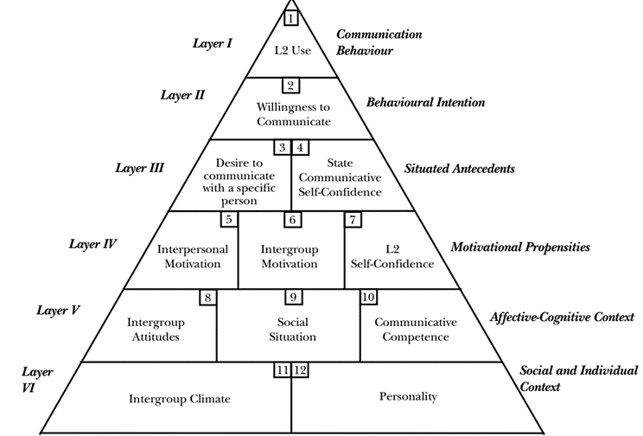
Figure1 - The heuristic pyramid model of L2 WTC
According to MacIntyre (2007), WTC provides the chance to combine psychological, linguistic, educational, and communicative approaches to L2 research. He describes WTC as a moment-to-moment dynamic state rather than a trait-like variable first introduced by McCroskey & Baer (1985). Moreover, he proposes that WTC does not assess communicative competence because it focuses on the psychological preparedness to communicate at a particular moment rather than the ability to use a language. Consequently, WTC would affect learners’ performance on learning processes and language tests in that assessment processes are immensely influenced by individual differences. Recognizing this, dynamic assessment (DA) as a process-based approach rooted in sociocultural theory offers new insights in this regard. DA has been proposed as a workable assessment approach for diagnostic purposes (Harding & Alderson & Brunfaut, 2015). To the knowledge of the researchers, no study has investigated if L2 WTC might have a facilitating role in learners’ performance in CDA procedures. Dynamic assessment has been proposed on the basis of the ground-breaking ideas of the Russian educational psychologist, Lev Vygotsky. In his sociocultural theory of learning, he posits that human being is primarily social. In other words, he believes that a part of human being is always anchored in the society; thus, a person’s ability or knowledge should always be addressed within the very context he is acting upon. Moreover, Vygotsky (1978) proposes the notion of Zone of Proximal Development (ZPD) that refers to "the distance between the actual developmental level as determined by independent problem solving and the level of potential development as determined through problem-solving under adult guidance or in collaboration with more capable peers" (p. 86). Figure 2 is an illustration of ZPD.
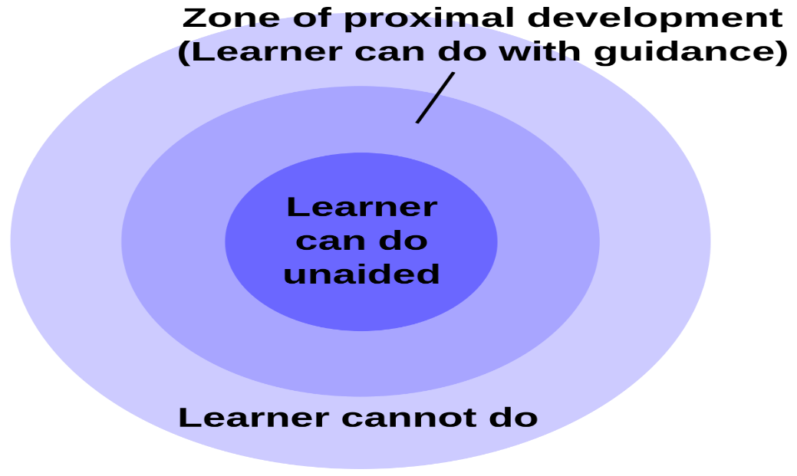
Figure 2 An illustration of the notion of ZPD.
In Vygotskian literature, ZPD is always compared with ZAD, that is, the zone of actual development. ZAD refers to the abilities that learners can do independently. Vygotsky always complains about the mainstream psychometric trends of assessing learners’ abilities and knowledge that address only learners’ ZAD. He believes that a true assessment happens only when both the independent performance (ZAD) and the assisted performance (ZPD) of learners are taken into account (Vygotsky, 1986, p. 187).
2.2. Dynamic assessment
The model of assessment developed based on Vygotsky’s ideas is called dynamic assessment. Lidz and Gindis (2003) state that “dynamic assessment is an approach to understanding individual differences and their implications for instruction that embeds intervention within assessment procedure” (p. 99). The intervention in the assessment procedure is usually termed as mediation. According to Lantolf (2009), DA requires a unification of assessment and instruction in a dynamic manner. DA has been conducted in two approaches so far. First, interactionist dynamic assessment in which the mediation is negotiated, individualistic and online. The second approach towards DA is interventionist approach in which the mediation is fixed, predetermined and standard. In other words, Lantolf (2009) posits that in interventionist DA “a prefabricated and fixed set of clues and hints is determined in advance and offered to learners as they move through a test item by item” (p. 360). Interventionist approach of DA can be conducted in two formats: The cake format in which mediation is presented to the learners item by item while the test is being conducted; and the sandwich format that follows a pretest-mediation-posttest scheme.
2.3. Computerized dynamic assessment (CDA)
The introduction of the DA as an alternative for traditional psychometric assessment procedures has triggered many valuable DA studies addressing different aspect of L2 that resulted in yielding fruitful results in support of DA (e.g., Ableeva, 2008; Ableeva & Lantolf, 2011; Anton, 2009; Birjandi & Ebadi, 2009, 2010; Jacobs, 2001; Kozulin & Garb 2002; Lantolf, 2009; Lantolf & Poehner, 2004, Poehner, 2007, 2008; Poehner & Lantolf, 2005; Summers, 2008). Nonetheless, a major drawback of nearly all of these studies is their practicality. In other words, most of ordinary DA procedures have addressed a very limited number of learners as well as very limited aspects of L2. Consequently, Lantolf and Poehner (2008) suggested computerized dynamic assessment as a way out of such practicality concerns.
2.4. L2 Computerized dynamic assessment studies

During the last ten years, a number of CDA studies have investigated different aspects of L2 (e.g., Oskoz, 2005; Pishghadam, & Barabadi, & Mehri Kamrood, 2011; Mehri Kamrood, 2011; Teo, 2012; Poehner & Lantolf, 2013; Poehner & Zhang & Lu, 2015, Ebadi & Saeedian, 2016; Yang & Qian, 2017; Mehri Kamrood, & Davoudi, & Amirian, & Ghaniabadi, 2018), yet most of the mentioned studies have investigated receptive skills (i.e., reading and listening) in L2 contexts. This is because of the fact that such skills lend themselves better to pre-planned and standardized mediations presented in CDA. Moreover, most of such studies have applied the cake format .Developing writing skill is very challenging for L2 learners. Indeed, “in terms of writing, producing a coherent, fluent, extended piece of writing is probably the most difficult thing there is to do in language. It is something most native speakers never master.” (Nunan, 2001, p. 271). The case gets more difficult when it comes to assessing learners’ writing skill through a CDA procedure. This is because of the fact that productive skills (i.e., speaking and writing) do not lend themselves to the same procedures applied in CDA of receptive skills due to the fact that one cannot control the response patterns of learners while taking the test. In other words, applying the cake format of interventionist DA, most of CDA of receptive skills (e.g., Poehner & Lantolf, 2013; Poehner, et al., 2015, Ebadi & Saeedian, 2016; Yang & Qian, 2017; Mehri Kamrood, et al, 2018) so far have used multiple-choice items for their test, because such a format allowed them to predict different response conditions and, therefore, develop the mediation schemes for each probable condition in advance. Nevertheless, the productive and emergent nature of writing does not allow for such formats. Hence, a sandwich format of interventionist CDA is more applicable for the writing skill. Zafarani and Maftoon (2016) conducted an interactionist CDA of writing in a Web 2.0 Asynchronous Collaborative Computer-Mediated Context; however, their study did solve the problem challenging most of ordinary DA procedures, that is, their being time-consuming and labor-intensive. This was because of the fact that they provided mediation during 16 weeks while interacting both with the group and the individual learners.
Zhang (2013) proposed a theoretical DA model for classroom EFL writing instruction applying information technology. However, even in theory, his design could hardly be accepted as a DA study. His model was an amalgam of the application of an automated scoring tool called Writing Roadmap 2.0 used in West Virginia public schools along with teacher and peers’ help as ZPD-based meditational tools while his theoretical model did not follow any of the mainstream rubrics that have been observed in the above-mentioned C-DA studies. Finally, only one study (Davoudi & Ataie-Tabar, 2015) has addressed CDA of writing for EFL learners by using a sandwich interventionist format of DA. In their study, the pretest and posttest were not carried out through computer, that is, they only provided learners with computerized mediation during their enrichment program. Consequently, their study was not fully computerized. This, in turn, did not solve the applicability concerns expected to be resolved through CDA. Moreover, they did not calculate and report learners’ learning potential score (LPS) as a key factor in diagnosing learners’ level of ZPD.
In view of the shortcomings mentioned above regarding the CDA studies addressing the writing skill in EFL context so far, the time is ripe to design and implement a more practical and accountable CDA of writing. Moreover, since individual differences are the most consistent predictor of success in second language learning (Dornyei, 2005), this study tends to measure the role of L2 WTC as a facilitator during the process of dynamic assessment. As mentioned above, WTC examines learners’ amount of tendency toward communication. Recognizing this, the present study aims at exploring how this tendency and readiness to enter into discourse can facilitate DA procedures and lead to better performance in L2 writing task.

3. Methodology
3.1. Participants
Out of 113 students who comprised the population of the study, 93 students (32 males and 61 females) were chosen through a TOEFL proficiency test. In fact, those students whose scores were one standard deviation below and above the mean were chosen as the main sample of the study. Learners’ age ranged from 21 to 43. They were all junior and senior students who had passed their courses of writing (i.e., paragraph development and essay writing) in Hakim Sabzevari University.

3.2. Instruments
TOEFL iBT
This screening test was conducted on the population to check the homogeneity of learners in terms of their language proficiency. The researchers chose one of the free authentic tests of TOEFL iBT available in ETS (2009) as the test. Learners took the test and, according to TOEFL rubrics, two expert raters scored their performance from 0 to 120. The main sample of the learners consisted of those whose score fell within one standard deviation of the mean score.
L2 WTC Questionnaire
As shown in Appendix A, 17 items from Weaver’s (2005) questionnaire were adapted and validated for assessing Iranian EFL learners’ WTC in English writing. Learners answered the questions on a 4-point Likert scale from 1. definitely not willing; 2. probably not willing; 3. probably willing; to 4. Definitely willing. Weaver (2005) used four-point scale to eliminate the possibility of neutral responses. In addition, he believes that the WTC questionnaire “…provides second language researchers and teachers with an important tool to determine students’ level of willingness across different speaking and Writing tasks/situations.” (p. 411).
The computerized dynamic test of writing (CDTW)
CDTW is a software package developed to assess and promote EFL learners’ writing ability. The procedure of designing and implementing the test is described independent writing tasks from (ETS, 2009) were used as the pretest. However, before embarking on the designing and developing the mediations for the dynamic part of the test, a two-phase piloting procedure was run. First, 20 learners with almost the same level of language proficiency of the original sample were asked to write about an independent writing task without receiving any mediations (non-dynamic administration). Then, their writings were analyzed in order to diagnose their points of weakness.

- Pretest: 40 minutes at least 250 words
- Prewriting: A general description of how an idea generation process could be conducted regarding the topic of the writing accompanied with some exemplifications under idea generation and get ready to write buttons.
  - idea generation/ questions as thought starters (what, how, why…) …There is no perfect idea as you might have different opinions.
  - get ready to write
- Introduction: Learners start writing the introduction while they can use hints and modify their writing. The mediation is presented in two boxes:
- Learning tip: a complete description of the structure of the introduction part and how and what kind of information should be presented.
- Support box: presents some leading phrases to start writing the introduction
- Body: Learners can write the body of their composition while they have access to the mediation and can modify their writing. The mediation is presented in two boxes
- Learning tip: helps learners about the way information should be organized and presented
- Support box: presents different options and examples through which learners can start the first and the following paragraphs in the body of their writing
- Conclusion: Learners can write the conclusion part of their composition while they have access to the mediation and can modify their writing. The mediation is presented in two boxes:
  - Learning tip: starts with what should be written in this part and then gives some examples for starting a concluding paragraph.
  - Support box: provides learners with learners with structures for writing the least sentences of the conclusion part.
- Native model of writing: as the last phase of the mediation process, learners are presented with a native model of writing through which they can compare and contrast their own writing with a native one so that they can check their inter-language forms and target forms.
- Finish saved tasks: After that, they have still the chance to modify every part of their own writing in this part.
- Posttest 1: they revise their original text based on what they noticed
- Posttest 2: revise their original text again after an interval of one month

Figure 3 - The scheme of mediations for task 2

The problematic issues were, then, taken as a departure point for developing an initial scheme of mediations in the dynamic part of the software. However, in order to come up with the most optimal scheme of mediation, the second phase of piloting was run in which 5 learners were required to write about a parallel topic while receiving online and individualistic mediations (interactionist DA administration). Based on the result of the second phase of piloting, the researchers modified their mediation scheme to the final version for each of the tasks. The whole process of the study is computerized. As such, in the first page of the software, learners are required to fill out their bio-data and then choose one of the tasks. In the second page of the software, either of the tasks chosen by the learner appears on the screen consisting of the parts shown in Appendix B.

3.3. The scoring procedure

Brown and Baily‘s (1984) analytic scoring system was used to rate learners’ compositions. This scoring scale assesses organization; logical development of ideas; grammar; mechanics; and style. Each of these sub-constructs has 20 points. Thus, learners’ scores range is from 0 to 100. In the present study, leaners’ writings were rated by an expert rater. In order to check for the reliability of scoring procedure, the tasks done by 25 learners were scored twice by the rater, the Pearson product moment correlation coefficient was r = 0.81 that is considered as a high rate of reliability.
3.4. Data collection and analysis
CDTW was administered in two sessions during two weeks, that is, learners did one of the tasks in one session and the other task was done in the second session in one week from the time they finished their first task. Moreover, as it is shown in Figure 3, in stage 9, learners were required to return to the software and rewrite both of the tasks in one month from the time they completed stage 8. Thus, the whole process for each task took six weeks. Having two tasks to complete in CDTW, each learner had two scores for each of the tests (i.e., pretest, posttest, and delayed posttest); hence, learners’ aggregate score for each of them was used as the final score. Using SPSS, paired sample t-test was run in order to answer the first research question. The second research question was analyzed using one-way ANOVA, as well as, planned contrasts. The third and the fourth research questions were explored through percentages and graphical representations.

4. Results and Discussion
4.1. Grouping learners according to their L2 WTC

This study sought to address two major issues of (1) designing and implementing a computerized dynamic test of English writing that both updates and solves the problems of the few CDTW conducted so far and (2) examining the facilitating role of WTC as a source of individual difference on leaners’ performance in terms of responsiveness to mediation in DA procedures. Therefore, learners were required to answer the WTC questionnaire. Their score ranged from 17 to 68 and they were classified into three groups of low WTC (scoring 17 to 33); mid WTC (scoring 34 to 50); and high WTC (scoring 51 to 68). Table 1 shows the distribution of learners among the three groups compared to the total number of learners.

Table 1 Distribution of Learners Based on Their Scores on WTC Questionnaire of Writing
WTC Level | Number of Learners | Total Number of Learners
High | 21 | 93
Mid | 40 | 93
Low | 32 | 93

4.2. Exploring learners’ responsiveness to mediation
The first research question sought to compare the learners’ pretest (non-dynamic) and posttest (dynamic) scores within each of WTC subgroups. Table 2 represents the results of paired sample t-tests applied for each of the subgroups.

Table 2 Comparing Independent and Mediated Performance of Learners within Groups
Groups | Number of learners | T | Sig | Cohen’s d
High | 21 | 13.35 | 0.01 | 0.7
Mid | 40 | 14.76 | 0.01 | 1.03
Low | 32 | 17.98 | 0.01 | 1.08

As it was expected, the results revealed significant differences between non-dynamic and dynamic scores of learners in all subgroups. As an effect size, Cohen’s d shows the standardized difference between two means. Based on Cohen’s (1988) classification, except for high WTC group that has a medium rate of Cohen’s d, both low and mid WTC groups have large ones. The significant differences as well as large effect sizes indicate that providing learners with mediation attuned to their ZPDs brings about significant changes in their final performance on the tests. In other words, from a Volscian perspective, learners’ performance on non-dynamic (traditional) tests can only account for learners’ ZAD that falls short of representing a full picture of learners’ repertoire of abilities in that it does not account for their ZPD, i.e., the abilities under construction but not fully internalized to be done independently. Consequently, through providing learners with ZPD-based mediation in DA processes, one can account for both the ZAD and ZPD. Almost all CDA studies have reported significant differences between learners’ independent and mediated performances (e.g., Barabadi, 2010; Mehri Kamrood, 2011; Poehner & Lantolf, 2013; Poehner, et al. 2015; Teo, 2012; Yang & Qian, 2017; Mehri Kamrood, et al., 2018). However, all of these studies have investigated receptive skills (i.e., reading and listening). Moreover, the result of the present study is in line with that of Davoudi and Ataee (2015) who reported a significant difference between the mediated and independent performance of the learners.
Nevertheless, as Poehner and Lantolf (2013) pointed out the expected improvement of learners’ performance when provided with mediation does not mean that they have developed their abilities, that is, it only shows how responsive they are to mediations they were provided with. In order to investigate if they have developed their abilities, one should see if they can maintain or even promote their current level in more challenging contexts such as a delayed post-test in the sandwich format of DA procedures. This issue will be in investigated in research question 4.

4.3. The role of willingness to communicate in CDTW
The second research question investigated if different levels of WTC could bring about significant differences in learners’ mediated performance. The results of one-way ANOVA revealed that there was an overall significant difference between learners’ posttest scores grouped by three levels of WTC, F = 6.4, P < .05. This finding indicates that willingness to communicate, as a source of individual differences, might have an effect on learners’ performance in CDA procedure.

Table 3 The Result of Planned Contrast Tests (Equality of Variances assumed)
Contrast | t | df | Sig. (2-tailed)
1(Low and Mid WTC) | 3.74 | 90 | 0.08
2(Mid and High WTC) | 4.07 | 90 | 0.05

Furthermore, as it is shown in Table 3, the planned contrasts revealed that having a mid WTC did not significantly increased the posttest (dynamic) score compared to that of the low WTC group, t (90) = 3.74, p < .08, yet having a high WTC in writing significantly increased the dynamic score compared to that of the mid WTC group, t (90) = 4.07, p < .05. To the knowledge of the researchers, few, if any, research in CDA have investigated the effect of different levels of WTC on the performance of learners so far.
4.5. The differentiating role of LPS on learners with similar independent performance

DA not only provides teachers with a more comprehensive picture of learners’ ability but also helps teachers differentiate among learners classified into the same level of ability according to their performance on non-dynamic tests. The third research question investigated the same matter. The pretest in this study represents the non-dynamic part of CDTW so the researchers found seven learners with the same scores of 34 in the pretest. As it is shown in Figure 4, these learners had different LPSs indicating the fact that they could not be considered as equal in terms of their writing abilities provided that their ZPDs were taken into account. In other words, the non-dynamic performance of the learners only represents their ZADs (i.e., their levels of independent performance) while they might have different levels of ZPD, that is, they might perform differently if they are provided with ZPD-based mediation. This finding resonates well with Vygotsky’s major criticism over the traditional IQ tests as being incomplete in that learners with the same so-called IQs performed differently on test items above their level when they were provided with mediations. Moreover, this finding is in line with those of the previous studies (Barabadi, 2010; Mehri Kamrood, 2011; Poehner & Lantolf, 2013; Poehner, et al. 2015; Yang & Qian, 2017).
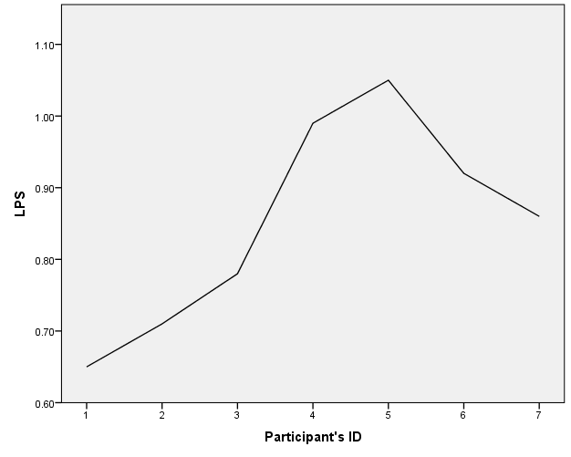

Figure 4 Different LPSs of 7 learners with the same pretest score of 34
4.6. Investigating learners’ development of writing ability in CDTW
One of the major claims raised by DA is that it not only assesses but also promotes and develops learners’ abilities at the same time. Nevertheless, as it was mentioned in discussion of the findings of the first research question, DA scholars such as Poehner and Lantolf (2013) believe that the expected improvement of learners’ performance in the posttest is not considered as a sign of development of learners’ writing ability but as representation of learners’ level of responsiveness to mediation. The development of the abilities is confirmed in DA studies only when they can transfer or transcend their current level to the new and more challenging assessment contexts (Poehner, 2007). In the sandwich format interventionist DA procedures this issue is addressed through delayed posttests (Poehner, 2007; Ableeva, 2010). In order to answer the fourth research question, the researchers compared the posttest (dynamic) and delayed posttest scores. Table 4 shows the descriptive statistics of comparing the two sets of scores.
Table 4 Descriptive Statistics for Posttest and Delayed Posttest Scores
 | N | Minimum | Maximum | Mean | Std. Deviation
Posttest | 93 | 33 | 86 | 58.83 | 13.94
Delayed Posttest | 93 | 36 | 87 | 61.25 | 11.63

As it is evident in in Table 4, comparing the means, we observe that learners have generally performed better in the delayed posttest. Moreover, the result of paired sample t-test revealed that there was a significant difference between learners’ posttest and delayed posttest scores, t (92) =3.434, P < 0.01. This could be considered as a sign of progress and development of learners’ writing skill. As for other CDA researchers, Ebadi and Saeedian (2016) reported absolute progress of learners by comparing their dynamic and transfer scores yet Mehri Kamrood, et al. (2018) reported that they did not promote but sustained their level of performance in the transfer tasks. Moreover, they proposed that if researchers break learners’ performance into the sub-constructs and then compare the dynamic and transfer scores, they might come up with more fruitful results that would help teachers have a better diagnosis of learners’ abilities. Figure 5 shows a comparison of learners’ performance by sub-constructs through posttest and delayed posttest scores in terms of their weighted percentages.
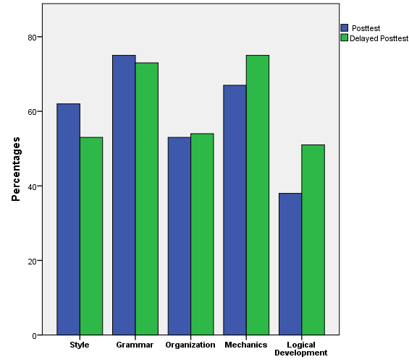

Figure 5 Comparing of posttest and delayed posttest scores of CDTW by sub-constructs

As we know, the posttest score is the counterpart of the dynamic score and delayed posttest score is the counterpart of transfer score in interventionist CDA procedures that were conducted in a cake format by Poehner and Lantolf (2013); Poehner, et al. (2015); and Mehri Kamrood, et al. (2018).The findings of the present study corroborate those of Mehri Kamrood, et al. (2018). That is, one can find instances of regression (e.g., style), sustenance (e.g., grammar and organization) and progress (e.g., logical development of ideas and mechanics) while comparing learners’ performance on the posttest and delayed posttest by sub-constructs. This comparison provides teachers with a more fine-grained diagnostic picture of learners’ writing ability in terms of different sub-constructs; therefore, it could be a substantial help for them for subsequent planning and developing remedial courses.

5. Conclusion and Implications
The purpose of the present study was twofold. First, observing the scarcity of CDA studies addressing the writing skill of EFL learners, this study tried to design and implement a computerized dynamic test of writing and then find answers for the questions raised in previous CDA studies conducted for receptive skills of reading and listening. Second, as learners’ performance rely heavily on how well they can negotiate with the mediation provided in the CDA procedures, the researchers tried to investigate if willingness to communicate a source of individual difference could have a facilitating role in CDA processes.
The findings of the present study revealed that through taking learners’ ZPD as well as their ZAD into consideration, CDTW could provide both learners and teachers with a more comprehensive picture of learners’ abilities while non-dynamic test could only account for learners ZAD (independent performance). Moreover, our findings confirmed the differentiating role of learning potential score (LPS) for learners who have the same performance on non-dynamic tests.Hence, the results of CDA procedures could provide substantial help in both diagnosing learners’ weaknesses and planning more individualized remedial courses and materials. Furthermore, through comparing learners’ performance on posttest (i.e., dynamic score) and delayed posttest (transfer score), the researchers proved that learners had sustained and developed their writing skill. Nevertheless, a more detailed comparison of learners’ performance by sub-constructs revealed that the researchers should be cognizant of the fact that there might be instances of regression, sustenance, and progress involved even when there is a general progress reported regarding the whole test. Finally, it was confirmed that WTC could have a facilitating role on learners’ performance in CDTW; however, it should be mentioned that L2 learners might have possibly been receiving L2 instructions during the time span between the tests (particularly between the posttest and the delayed posttest). Nonetheless, the results of planned contrasts revealed that only those who had a high WTC performed significantly better than those with low and mid WTC. Thus, providing learners with the contexts in which their L2 WTC increases could be conducive to fact that they make better use of the mediations in CDA procedures. This, in turn, could lead to the development of learners’ abilities that is one of the major goals of conducting CDA procedures.
Designing and implementing CDA of productive skills such as writing is very demanding, yet through our piloting phases we tried to provide the best ZPD-based mediational scheme possible. Nonetheless, we acknowledge that future researchers might develop more individualistic and negotiated schemes of mediation that are more in line with Vygotskian perspectives. Another limitation of the study was the fact that, our CDTW was run in an offline mode. This decreased of the accessibility as well as the user-friendliness of the software only to those who could receive our software. Thus, another possible line of research might be developing online CDTW that embraces larger numbers of participants and wider arrays of constructs.
References
Ableeva, R. (2008). The effects of dynamic assessment on L2 listening comprehension. In J. P. Lantolf & M. E. Poehner (Eds.), Sociocultural theory and the teaching of second languages (pp. 57-86). London: Equinox.
Ableeva, R. (2010). Dynamic assessment of listening comprehension in second language learning (Doctoral dissertation, The Pennsylvania State University). Retrieved from https://etda.libraries.psu.edu/files/ final submissions/5374
Ableeva, R., & Lantolf, J. P. (2011). Mediated dialogue and the microgenesis of second language listening comprehension. Assessment in Education: Principles, Policy & Practice, 18(2), 133-149.doi:10.1080/0969594x.2011.555330
Anton, M. (2009). Dynamic assessment of advanced second language learners. Foreign Language Annals, 42(3), 576-598.
Bachman, L. F. (1990). Fundamental considerations in language testing. Oxford: Oxford University Press.
Baghaei, P., & Dourakhshan, A. (2012). The relationship between willingness to communicate and success in learning English as a foreign language. Modern Journal of Applied Linguistics, 4(2), 53-67.
Barabadi, E. (2010). Designing computerized dynamic assessment of L2 reading comprehension of Iranian university students and its comparison with static test of L2 reading comprehension (Unpublished master’s thesis). Ferdowsi University of Mashhad, Mashhad, Iran.
Birjandi, P., & Ebadi, S. (2009). Issues in dynamic assessment. English Language Teaching, 2(4), 188-198.
Birjandi, P., & Ebadi, S. (2010). Exploring learners’ microgenetic development in L2 dynamic assessment via online Web 2.0 technology. Paper presented in IELTI 5, University of Tehran, Tehran, Iran.
Brown, J. D., & Bailey, K. M. (1984). A categorical instrument for scoring second language writing skills. Language Learning, 34(4), 21-38. doi:10.1111/j.1467-1770.1984.tb00350.x
Bukhari, S. F., Cheng, X., & Khan, S. A. (2015). Willingness to communicate in English as a second language: A case study of Pakistani undergraduates. Journal of Education and Practice, 6(29), 39-44.
Cohen, J. (1988). Statistical power analysis for the behavioral sciences (2nd Ed.). Hillsdale, NJ: Lawrence Earlbaum Associates.
Davoudi, M., & Ataie-Tabar, M. (2015). The effect of computerized dynamic assessment of L2 writing on Iranian EFL learners' writing development. International Journal of Linguistics and Communication, 3(2), 176-186.
Dornyei, Z. (2005). The psychology of the language learner: individual differences in second language acquisition. Mahwah, NJ: Lawrence Erlbaum.
Ebadi, S., & Saeedian, A. (2016). Exploring transcendence in EFL learners’ reading comprehension through computerized dynamic assessment. Iranian Journal of Language Teaching Research, 4(1), 27-45
Ellis, R. (1990). Afferent-efferent connections and neutrality-modifications in imaginative and perceptual consciousness. Man and World, 23, 23-33
ETS (2009). The official guide to the TOEFL ® Test. (3rd Ed.). The McGraw-Hill Companies, Inc.
Harding, L., & Alderson, C. J., & Brunfaut, T. (2015). Diagnostic assessment of reading and listening in a second or foreign language: Elaborating on diagnostic principles. Language Testing, 32(3), 317–336. doi: 10.1177/0265532214564505
Jacobs, E. L. (2001). The effects of adding dynamic assessment components to a computerized preschool language screening test. Communication Disorders Quarterly, 22(4), 217–226.
Khorasani, M., & Amini Harsini, M. (2015). The relationships among willingness to communicate, topic familiarity and Iranian intermediate EFL learners’ writing ability. International Journal of Language Learning and Applied Linguistics World, 8(1), 186-196.
Kozulin, A., & Garb, E. (2002). Dynamic assessment of EFL text comprehension of at-risk students. School Psychology International, 23(1), 112–127.
Lantolf, J. P. (2009). Dynamic assessment: The dialectic integration of instruction and assessment. Language Teaching, 42(3), 355-368.
Lantolf, J. P., & Poehner, M. E. (2004). Dynamic assessment of L2 development: Bringing the past into the future. Journal of Applied Linguistics, 1(1), 49–74. doi:10.1558/japl.1.1.49.55872
Lantolf, J. P., & Poehner, M. E. (2008). Dynamic assessment. In E. Shohamy & N. H. Hornberger (Eds.), The encyclopaedia of language and education: Language testing and assessment (2nd Ed., Vol. 7, pp. 273–285). New York: Springer Science+Business Media LLC.
Lidz, C. S., & Gindis, B. (2003). Dynamic assessment of the evolving cognitive functions in children. In A. Kozulin, B. Gindis, V.S. Ageyev & S.M. Miller (Eds.), Vygotsky's educational theory in cultural context (pp. 100-105). New York: Cambridge University.
MacIntyre, P. D., (2007). Willingness to communicate in the second language: Understanding the decision to speak as a volitional process, Modern Language Journal, 91, 564-576.
MacIntyre, P., Dornyei, Z., Clement, R., & Noels, K. (1998). Conceptualizing willingness to communicate in a L2: A situational model of L2 confidence and affiliation. Modern Language Journal, 82(4), 545-562.
Maftoon, P., & Amiri, M. (2012). Willingness to communicate in the second language acquisition: A case study on Iranian 2-year old kids. Journal of Studies in teaching and Learning English. 1(1), 135-160.
Mahmoodi, M., & Moazam, I. (2014). Willingness to communicate (WTC) and L2 achievement: The case of Arabic language learners. Procedia - Social and Behavioral Sciences, 98 DOI: 10.1016/j.sbspro.2014.03.518
McCroskey, J. C., & Baer, J. E. (1985). Willingness to communicate: The construct and its measurement. Paper presented at the annual convention of the Speech Communication Association, Denver, CO
Mehri Kamrood, A. (2011). Assessing and promoting the grammatical knowledge of the Iranian EFL learners through computerized dynamic test of grammar: An interventionist approach (Unpublished master’s thesis). University of Tehran, Tehran, Iran.
Mehri Kamrood, A., & Davoudi, M., & Amirian, M. R., & Ghaniabadi, S. (2018). Transcendence of learning in an online computerized dynamic test of English listening. CALL-EJ. 19(1), 23-42.
Nunan, D. (2001). Second English teaching and learning. Beijing: Foreign Language Teaching and Research Press.
Oskoz, A. (2005). Students' dynamic assessment via online chat. CALICO Journal, 22 (3), 513-536.
Poehner, M. E. (2007). Beyond the test: L2 dynamic assessment and the transcendence of mediated learning. The Modern Language Journal, 91, 323–340.
Poehner, M. E., & Lantolf, J. P. (2005). Dynamic assessment in the language classroom. Language Teaching Research, 9, 1–33.
Poehner, M. E., & Lantolf, J. P. (2013). Bringing the ZPD into the equation: Capturing L2 development during computerized dynamic assessment (C-DA). Language Teaching Research, 17(3), 323-342. doi:10.1177/1362168813482935
Poehner, M. E., & Zhang, J., & Lu, X. (2015). Computerized dynamic assessment (C-DA): Diagnosing L2 development according to learner responsiveness to mediation. Language Testing, 32(3), 1-21. doi: 10.1177/0265532214560390
Pishghadam, R., & Barabadi, E., & Mehri Kamrood, A. (2011). The differing effect of computerized dynamic assessment of L2 reading comprehension on high and low achievers. Journal of Language Teaching and Research, 2(6), 1353-1358. doi:10.4304/jltr.2.6.1353-1358
Summers, R. (2008). Dynamic assessment: Toward a model of computer- mediated dialogic engagement. (Doctoral dissertation, The Pennsylvania State University). Unpublished doctoral dissertation.
Teo, A. (2012). Promoting EFL students’ inferential reading skills through computerized dynamic assessment. Language Learning and Technology, 16(3). 10-20. Retrieved from http://llt.msu.edu/issues/october2012/action.pdf
Vygotsky, L. S. (1978). Mind in society: The development of higher psychological processes. Cambridge, M A: Cambridge University Press.
Vygotsky, L. S. (1986). Thought and Language. Cambridge, MA: The MIT Press.
Weaver, C. (2005). Using the Rasch model to develop a measure of second language learners’ willingness to communicate within a language classroom. Journal of Applied Measurement, 6(4), 396–415.
Yang, Y., & Qian, D. D. (2017). Assessing English reading comprehension by Chinese EFL learners in computerized dynamic assessment. Language Testing in Asia, 7(1), 3-15. doi: 10.1186/s40468-017-0042-3
Yashima, T. (2002). Willingness to communicate in a second language: The Japanese EFL context. Modern Language Journal, 86(1), 54–66.
Yashima, T., & Tanaka, T. (2001). Roles of social support and social skills in the intercultural adjustment of Japanese adolescent sojourners in the USA. Psychological Reports, 88, 1201–1210
Zafarani, Z., & Maftoon, P. (2016). Investigating dynamic writing assessment in a Web 2.0 asynchronous collaborative computer-mediated context. Iranian Journal of Applied Linguistics, 19, 195-240. doi:10.29252/ijal.19.2.195.
Zhang, Y. (2013). The theoretical construction of a dynamic assessment mode in Chinese tertiary EFL writing class with online teaching and scoring systems, CALL-EJ, 14(2), 38-50.
APPENDICES
Appendix A
List of the 34 speaking and writing tasks/situations on the L2 WTC questionnaire, (Weaver, 2005, p. 415)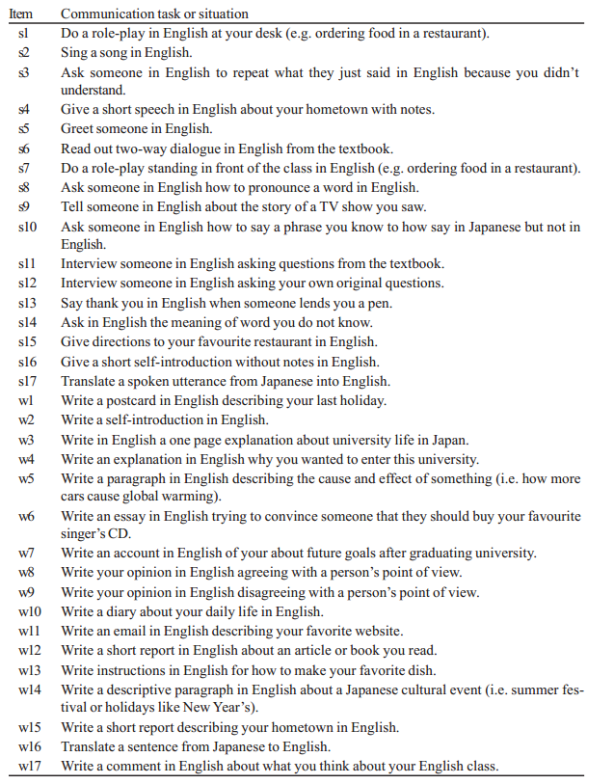

Appendix B
The scheme of mediations for task 2

- Pretest : 40 minutes at least 250 words
- Prewriting: A general description of how an idea generation process could be conducted regarding the topic of the writing accompanied with some exemplifications under idea generation and get ready to write buttons.
  - idea generation/ questions as thought starters (what, how, why…)…There is no perfect idea as you might have different opinions.
  - get ready to write
- Introduction: Learners start writing the introduction while they can use hints and modify their writing. The mediation is presented in two boxes:
- Learning tip: a complete description of the structure of the introduction part and how and what kind of information should be presented.
- Support box: presents some leading phrases to start writing the introduction
- Body: Learners can write the body of their composition while they have access to the mediation and can modify their writing. The mediation is presented in two boxes
- Learning tip: helps learners about the way information should be organized and presented
- Support box: presents different options and examples through which learners can start the first and the following paragraphs in the body of their writing
- Conclusion: Learners can write the conclusion part of their composition while they have access to the mediation and can modify their writing. The mediation is presented in two boxes:
  - Learning tip: starts with what should be written in this part and then gives some examples for starting a concluding paragraph.
  - Support box: provides learners with learners with structures for writing the least sentences of the conclusion part.
- Native model of writing: as the last phase of the mediation process, learners are presented with a native model of writing through which they can compare and contrast their own writing with a native one so that they can check their inter-language forms and target forms.
- Finish saved tasks: After that, they have still the chance to modify every part of their own writing in this part.
- Posttest 1: they revise their original text based on what they noticed
- Posttest 2: revise their original text again after an interval of one month

PhD student of TEFL, Rahil.Behshad@yahoo.com, Department of English Language and Literature, Hakim Sabzevari University, Iran
Assistant professor, smr.amirian@gmail.com, Department of English Language and Literature, Hakim Sabzevari University, Iran (Corresponding Author)
Assistant professor, davoudi2100@gmail.com , Department of English Language and Literature, Hakim Sabzevari University, Iran
Assistant professor, sghaniabadi@yahoo.com , Department of English Language and Literature, Hakim Sabzevari University, Iran

